|  |  |
| --- | --- |
| **Ex No. 1 & 2** | **Install Google App Engine. Create hello world app and other simple web applications using python/java. Use GAE launcher to launch the web applications** |

**Introduction**

## Google Cloud Platform (GCP)

* + **Google Cloud Platform** (**GCP**), offered by [Google,](https://en.wikipedia.org/wiki/Google) is a suite of [cloud](https://en.wikipedia.org/wiki/Cloud_computing) [computing](https://en.wikipedia.org/wiki/Cloud_computing) services that runs on the same infrastructure that Google uses internally for its end-user products, such as [Google Search, Gmail,](https://en.wikipedia.org/wiki/Google_Search) [file storage,](https://en.wikipedia.org/wiki/Google_Drive) and [YouTube.](https://en.wikipedia.org/wiki/YouTube)
  + Alongside a set of management tools, it provides a series of modular cloud services including computing, [data storage](https://en.wikipedia.org/wiki/Computer_data_storage)[, data analytics a](https://en.wikipedia.org/wiki/Data_analysis)nd [machine learning.](https://en.wikipedia.org/wiki/Machine_learning)
  + Google Cloud Platform provides [infrastructure as a service, platform as](https://en.wikipedia.org/wiki/Infrastructure_as_a_service) [a](https://en.wikipedia.org/wiki/Platform_as_a_service) [service, a](https://en.wikipedia.org/wiki/Platform_as_a_service)nd [serverless computing e](https://en.wikipedia.org/wiki/Serverless_computing)nvironments.

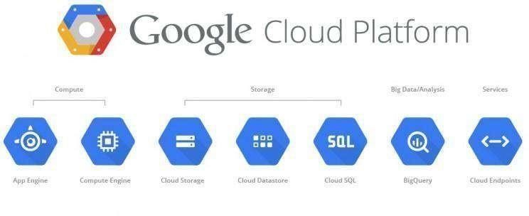

* **Platform as a Service (PaaS)** o Cloud computing service which provides a computing platform and a solution stack as a service.
  + Consumer creates the software using tools and/or libraries from the provider. o Provider provides the networks, servers, storage, etc.

##  Google App Engine:

* + Google App Engine was first released as a beta version in April 2008.
  + It is a is a Platform as a Service (PaaS) cloud computing platform for developing and hosting web applications in Google-managed data centers.
  + Google‘s App Engine opens Google‘s production to any person in the world at no charge.
  + Google App Engine is software that facilitates the user to run his web applications on Google infrastructure.
  + It is more reliable because failure of any server will not affect either the performance of the end user or the service of the Google.
  + It virtualizes applications across multiple servers and data centers.
    - Other cloud-based platforms include offerings such as Amazon Web Services and Microsoft's Azure Services Platform.  **Introduction of Google App Engine**
* Google App Engine lets you run your web applications on Google's infrastructure. App Engine applications are easy to build, easy to maintain,and easy to scale as your traffic and data storage needs grow. With App Engine, there are no servers to maintain: You just upload your application, and it's ready to serve your users.
* You can serve your app from your own domain name (such as https:/[/www.example.com/)](http://www.example.com/)) using Google Apps. Or, you can serve your app using a free name on the appspot.com domain. You can share your application with the world, or limit access to members of your organization.
* Google App Engine supports apps written in several programming languages. With App Engine's Java runtime environment, you can build your app using standard Java technologies, including the JVM, Java servlets, and the Java programming language—or any other language using a JVM-based interpreter or compiler, such as JavaScript or Ruby. App Engine also features a dedicated Python runtime environment, which includes a fast Python interpreter and the Python standard library. The Java and Python runtime environments are built to ensure that your application runs quickly, securely, and without interference from other apps on the system.
* With App Engine, you only pay for what you use. There are no set-up costs and no recurring fees. The resources your application uses, such as storage and bandwidth, are measured by the gigabyte, and billed at competitive rates. You control the maximum amounts of resources your app can consume, so it always stays within your budget. App Engine costs nothing to get started. All applications can use up to 500 MB of storage and enough CPU and bandwidth to support an efficient app serving around 5 million page views a month,

absolutely free. When you enable billing for your application, your free limits are raised, and you only pay for resources you use above the free levels.  **Architecture of Google App Engine**

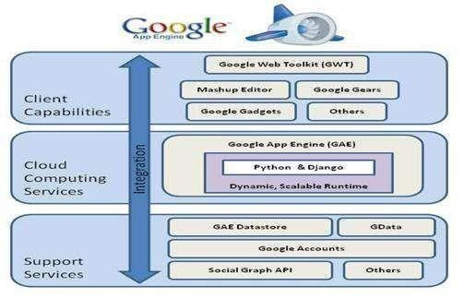

## Features of Google App Engine

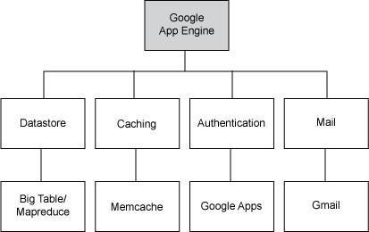

* **GAE Application Environment:**
* Google App Engine makes it easy to build an application that runs reliably, even under heavy load and with large amounts of data. App Engine includes the following features:
* Persistent storage with queries, sorting and transactions
* Automatic scaling and load balancing
* APIs for authenticating users and sending email using Google Accounts
* Task queues for performing work outside of the scope of a web request
* Scheduled tasks for triggering events at specified times and regular intervals
* Dynamic web serving, with full support for common web technologies

## Java Runtime Environment

* You can develop your application for the Java runtime environment using common Java web development tools and API standards. Your app interacts with the environment using the Java Servlets standard, and can use common web application technologies such as Java Server Pages
* The Java runtime environment uses Java 6. The App Engine Java SDK supports developing apps using either Java 5 or 6. The environment includes the Java SE Runtime Environment (JRE) 6 platform and libraries. The restrictions of the sandbox environment are implemented in the JVM. An app can use any JVM byte code or library feature, as long as it does not exceed the sandbox restrictions. For instance, byte code that attempts to open a socket or write to a file will throw a runtime exception.
* Your app accesses most App Engine services using Java standard APIs. For the App Engine data store, the Java SDK includes implementations of the Java Data Objects (JDO) and Java Persistence API (JPA) interfaces. Your app can use the JavaMail API to send email messages with the App Engine Mail service. The java.net HTTP APIs accesses the App Engine URL fetch service.
* App Engine also includes low-level APIs for its services to implement additional adapters, or to use directly from the application. See the documentation for the data store, memcache, URL fetch, mail, images and Google Accounts APIs. Typically, Java developers use the Java programming language and APIs to implement web applications for the JVM. With the use

of JVM-compatible compilers or interpreters, you can also use other languages to develop web applications, such as JavaScript, Ruby.

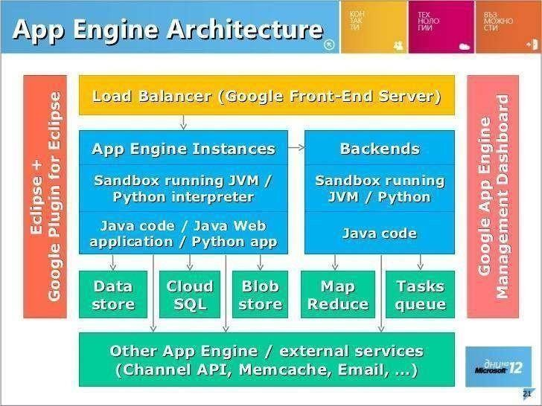

## Workflow of Google App Engine

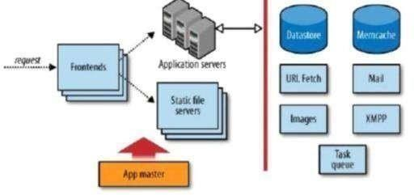

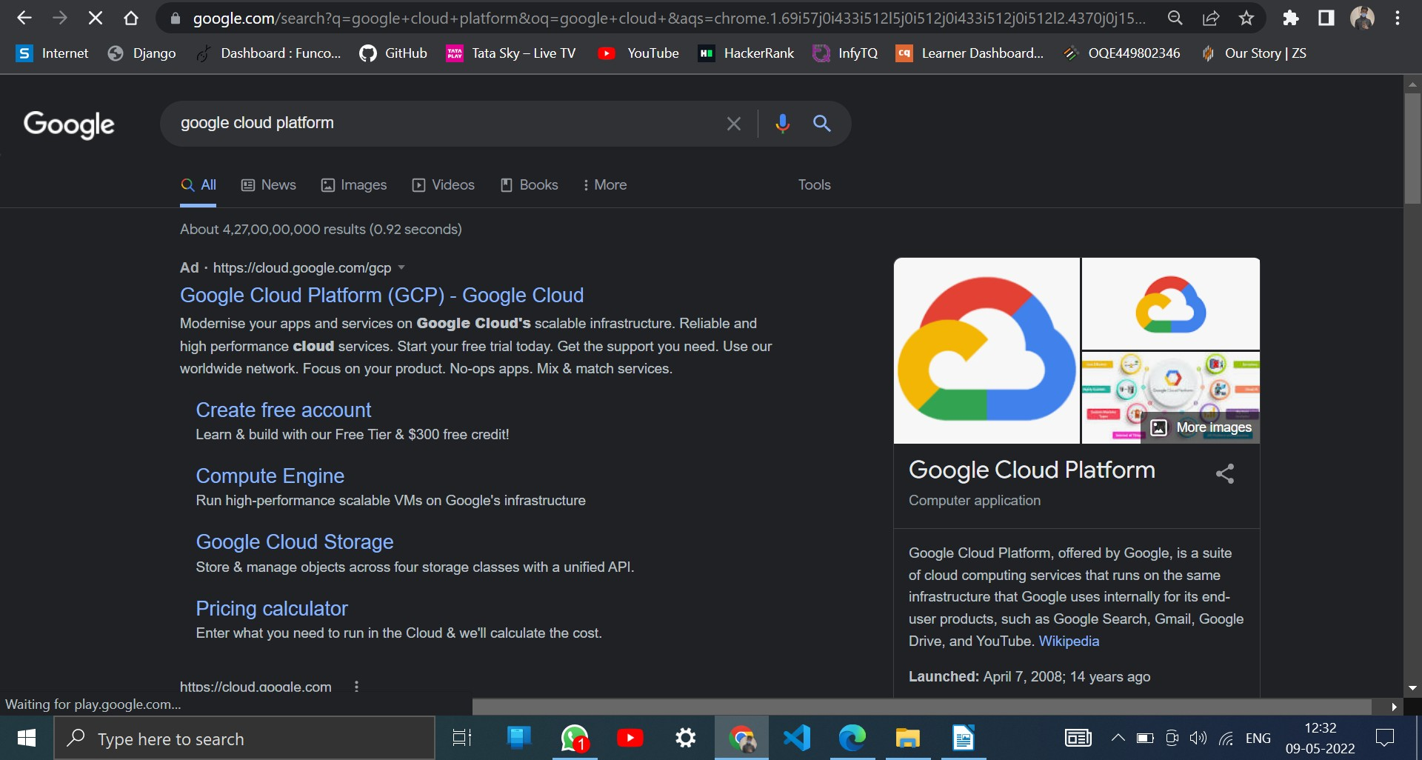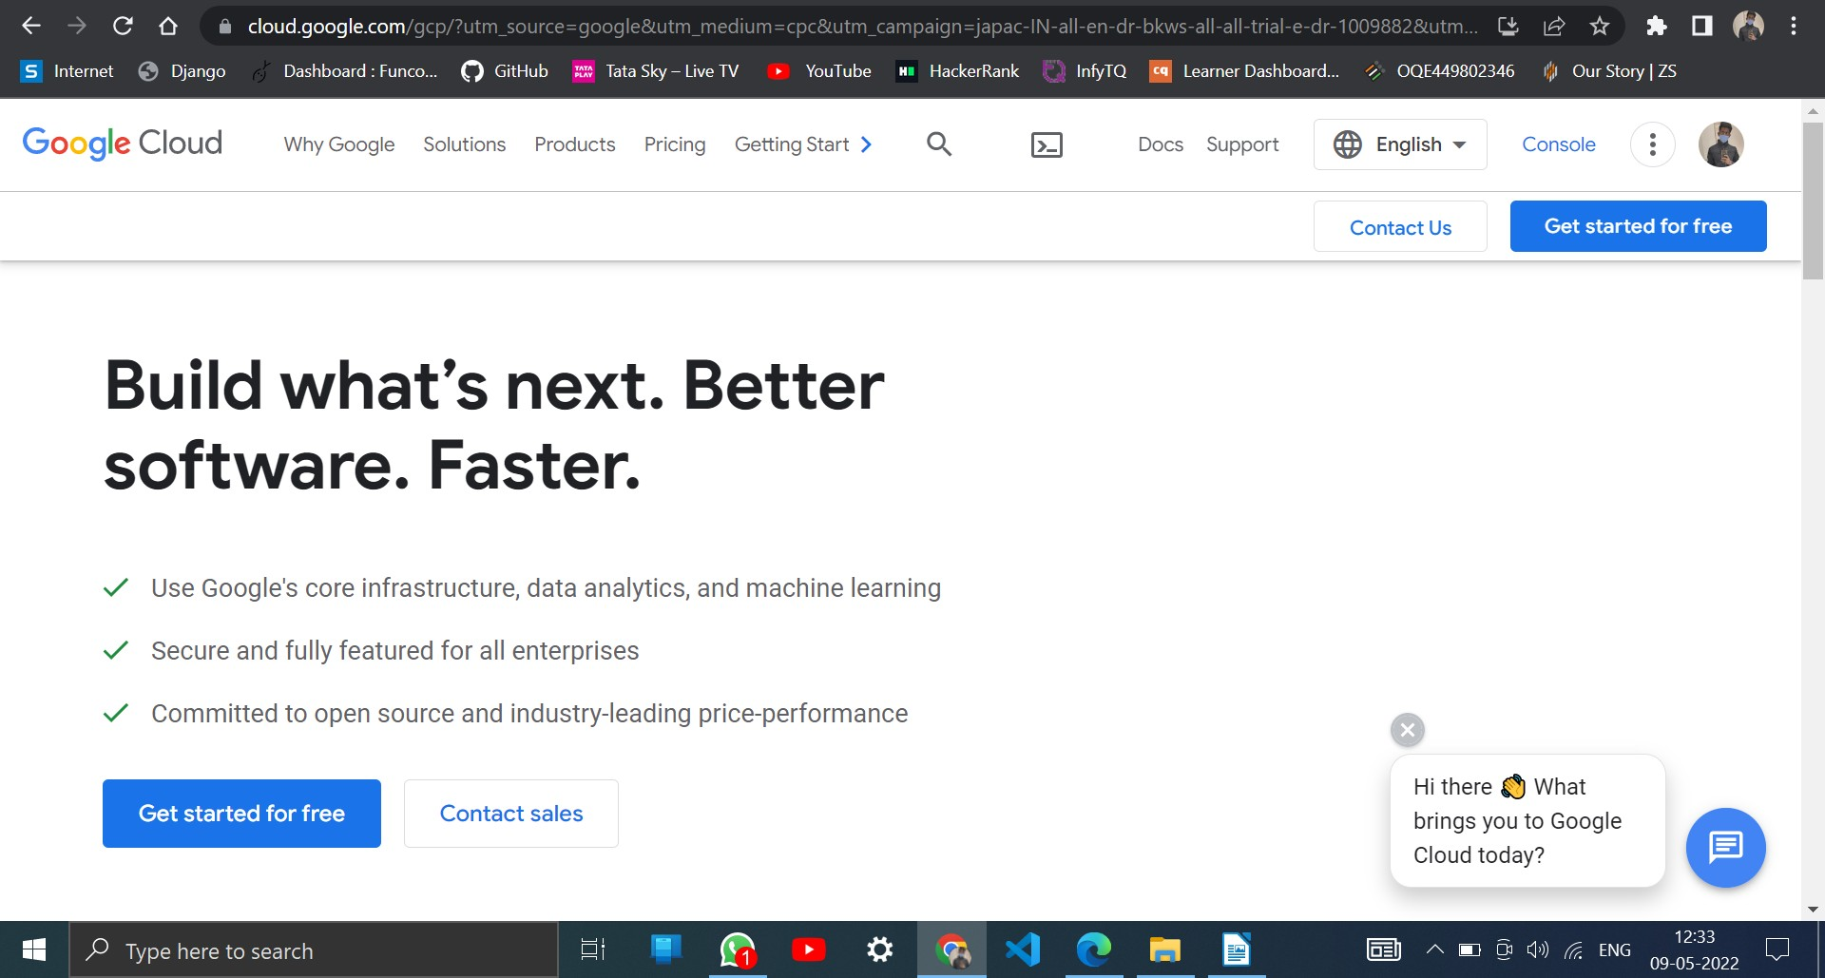

**Step1 : Login to** [**www.cloud.google.com**](http://www.cloud.google.com/)

## Step2 : Goto Console

**Step 3 : Google Cloud Platform is shown**

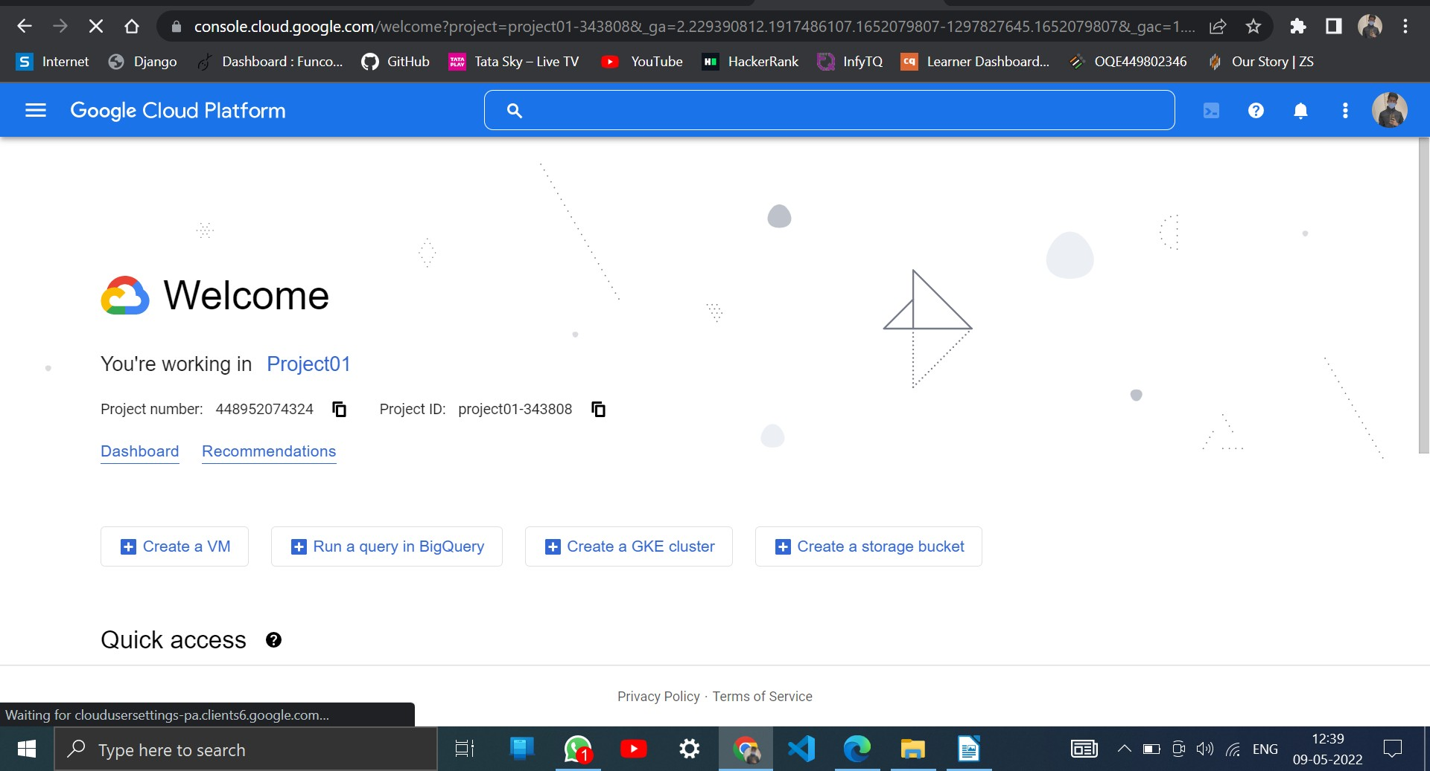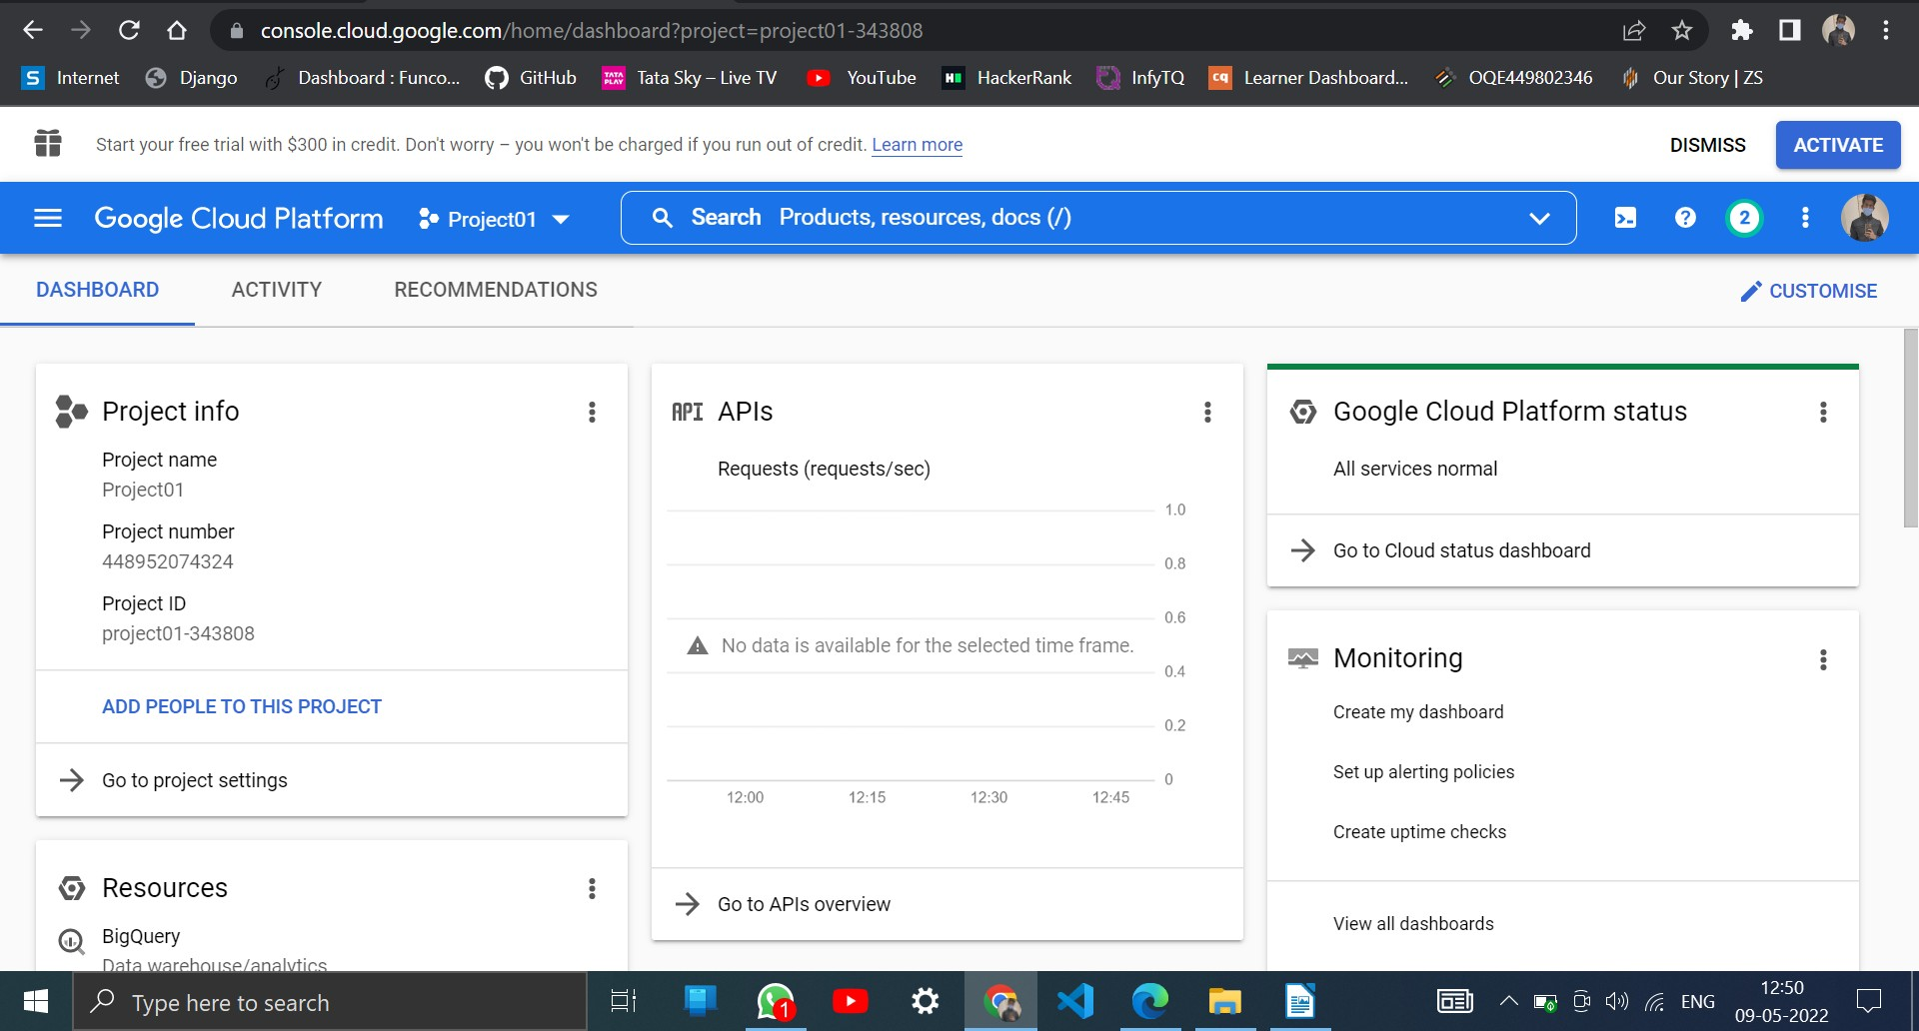

## Step 4 : Click Dashboard in the Google Cloud Plaform

**Step 5 : Dashboard in the Google Cloud Plaform**

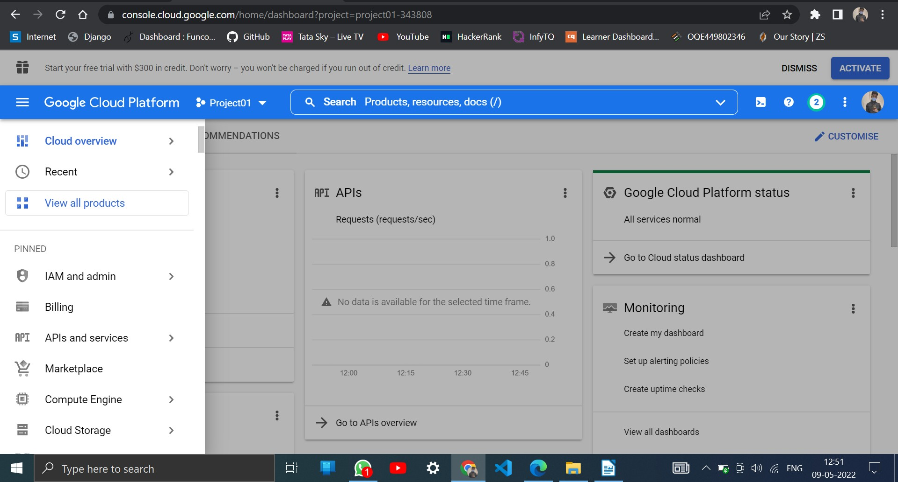

## Step 6 : Click New Project and give unique Project Name.

Example : pravin-cloud-project

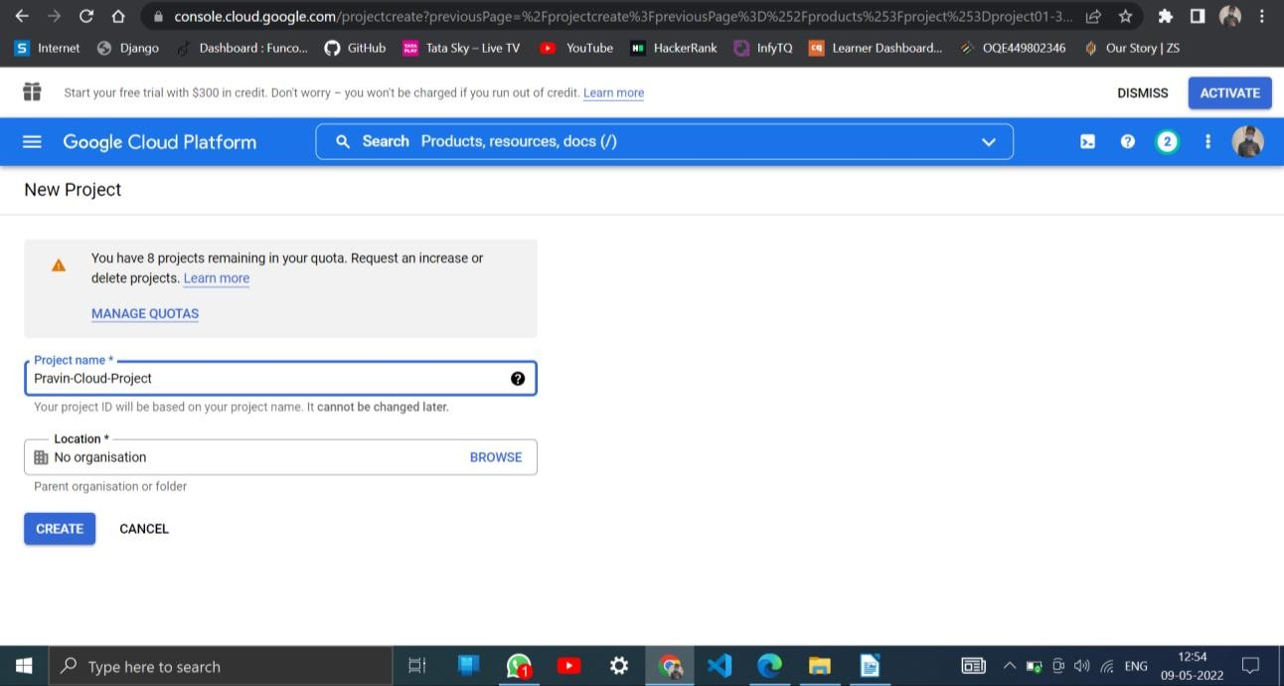

## Step 7 : Google App Engine is initated

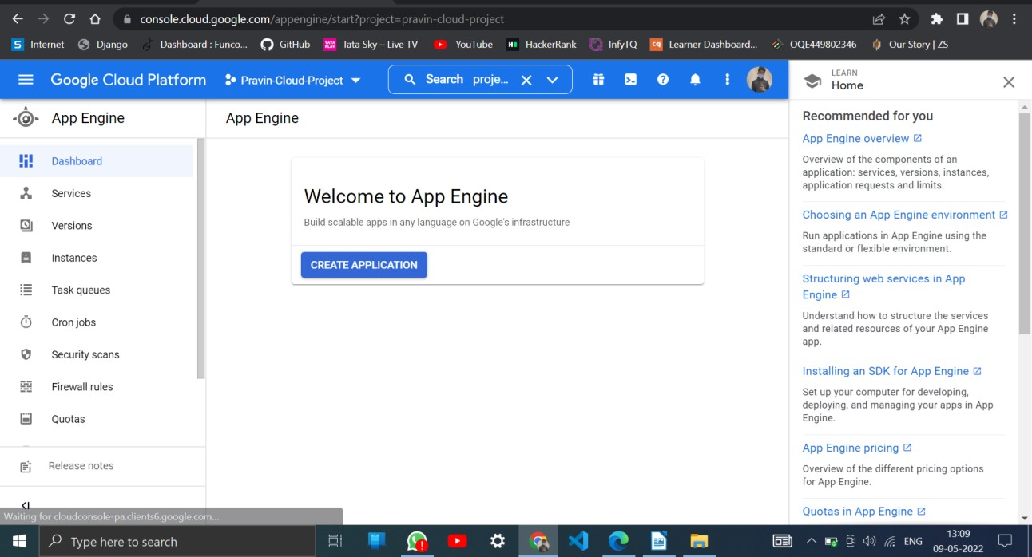

**Step 8 : Click create Application**

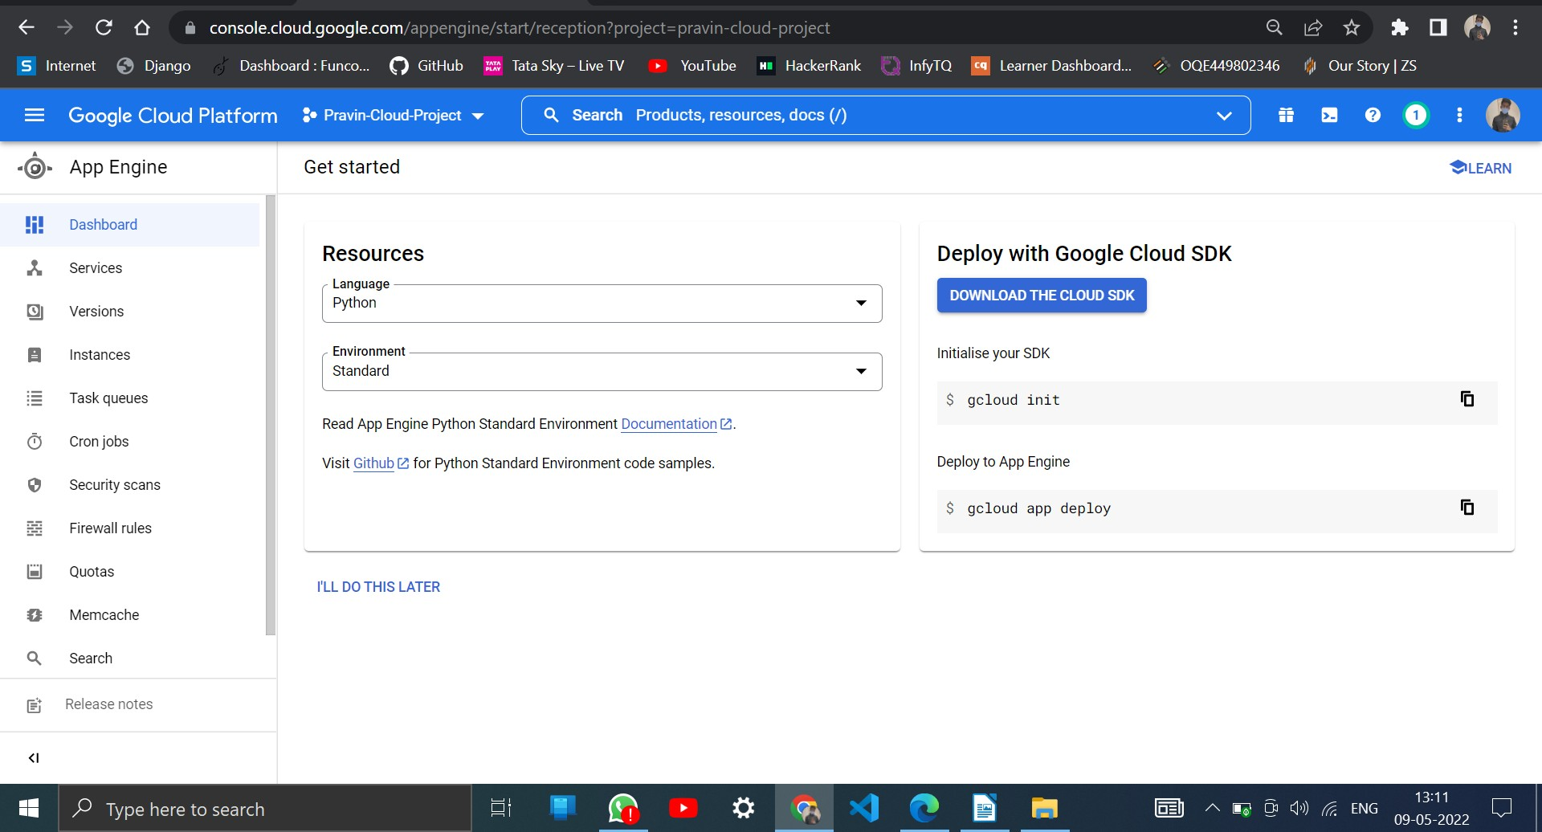

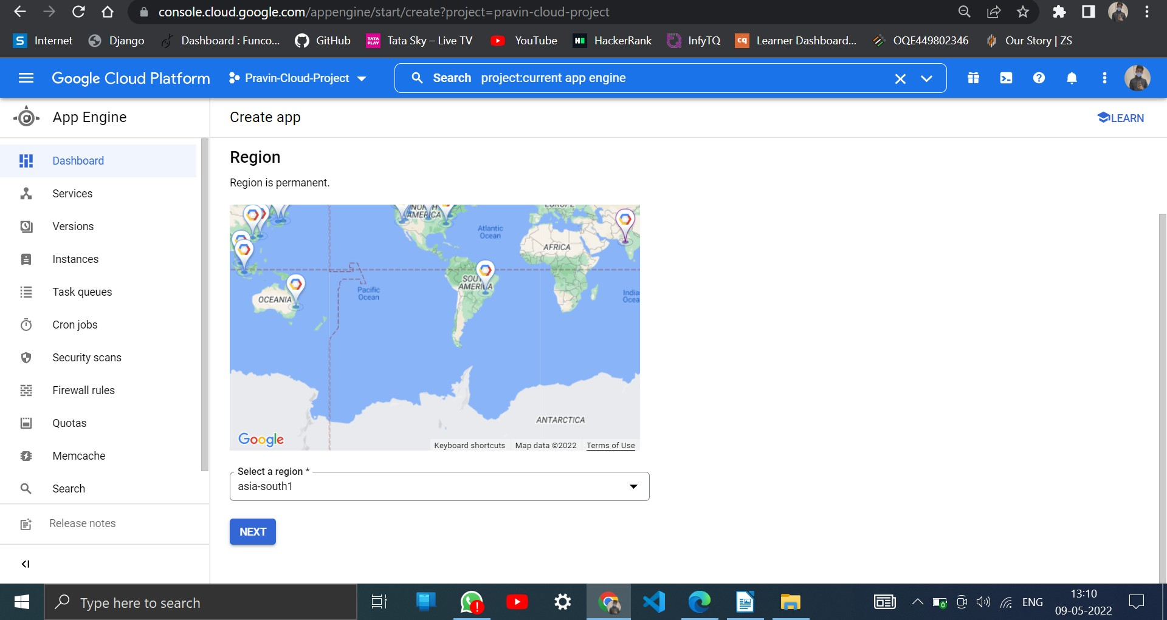

## Step 9 : Create app and Select Language Python

**Step 10 : Python app is created in Google App Engine**

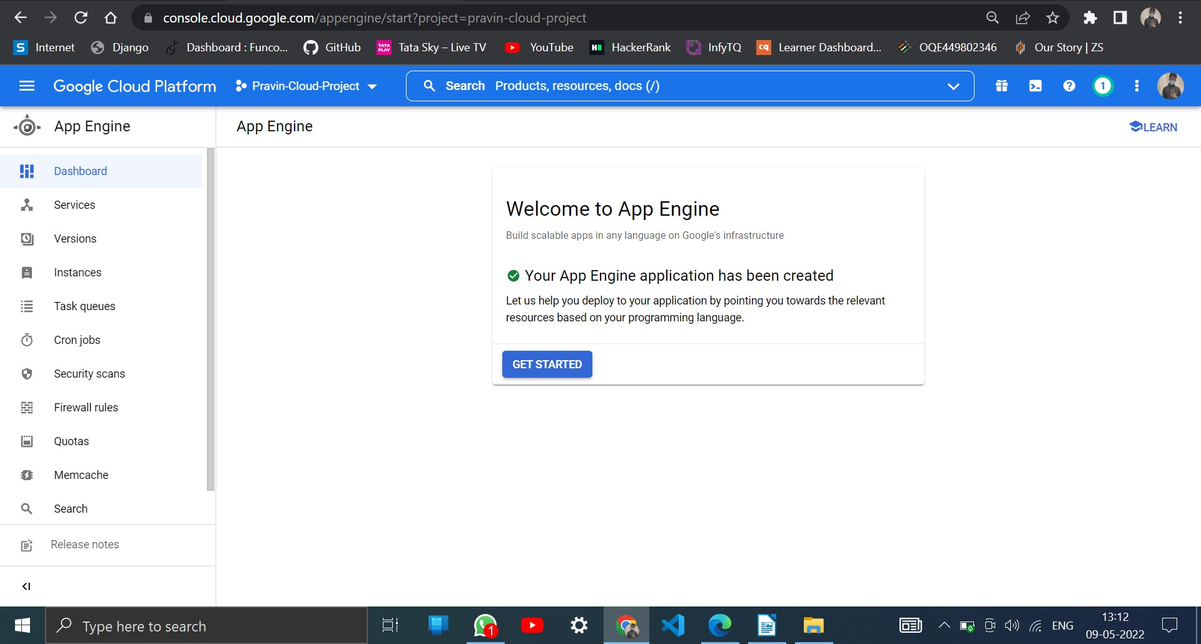

## Step 12 : Click Cloud Shell in the Pravin-Cloud-Project

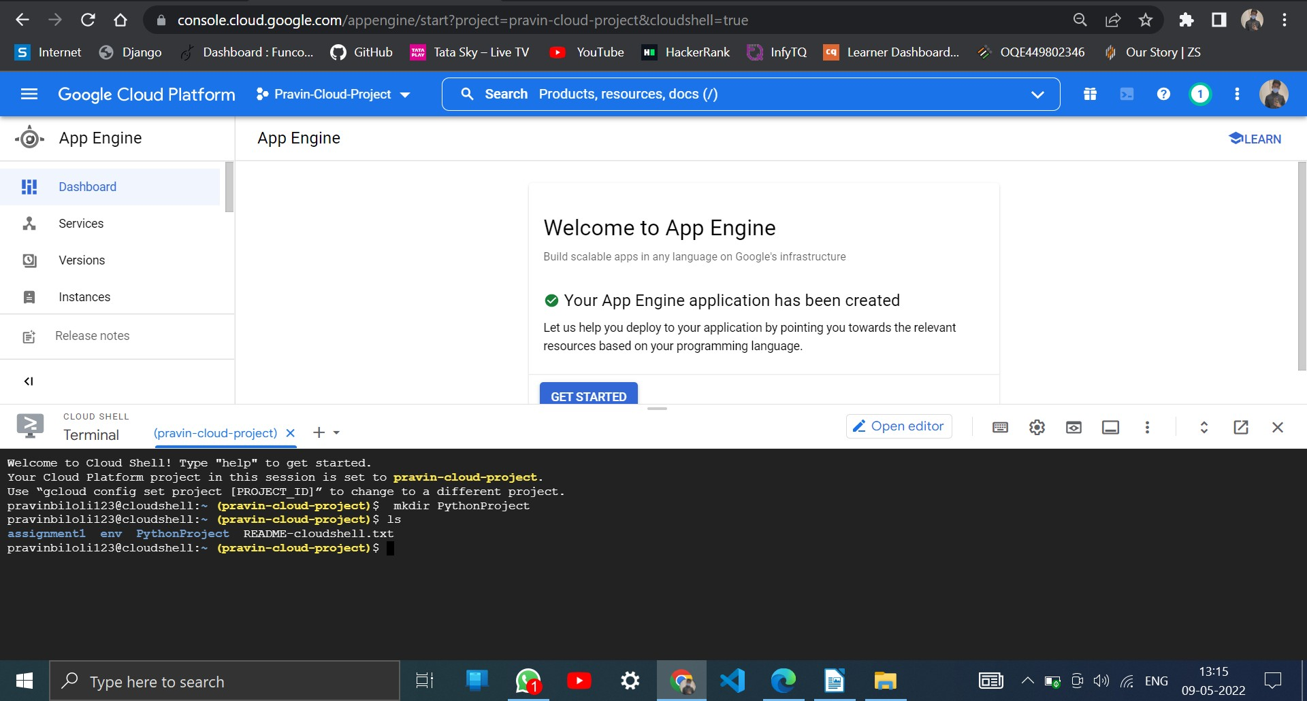

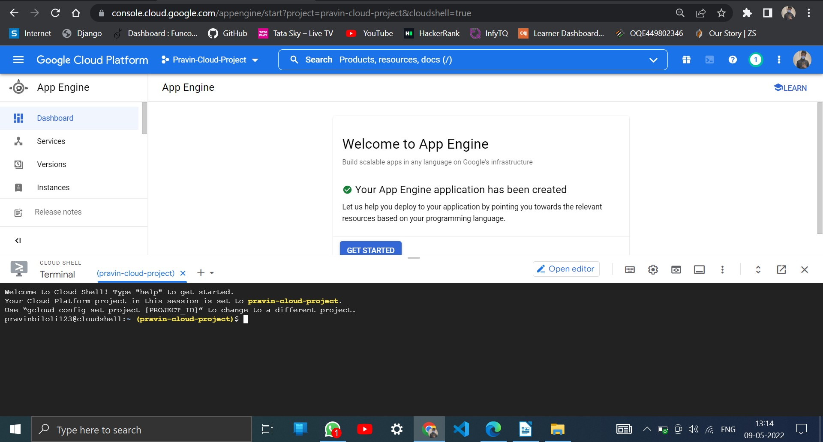

**Step 13 : Create a Directory PythonProject using mkdir command**

Syntax : mkdir PythonProject

## Step 14 : Click Editor to create Python application

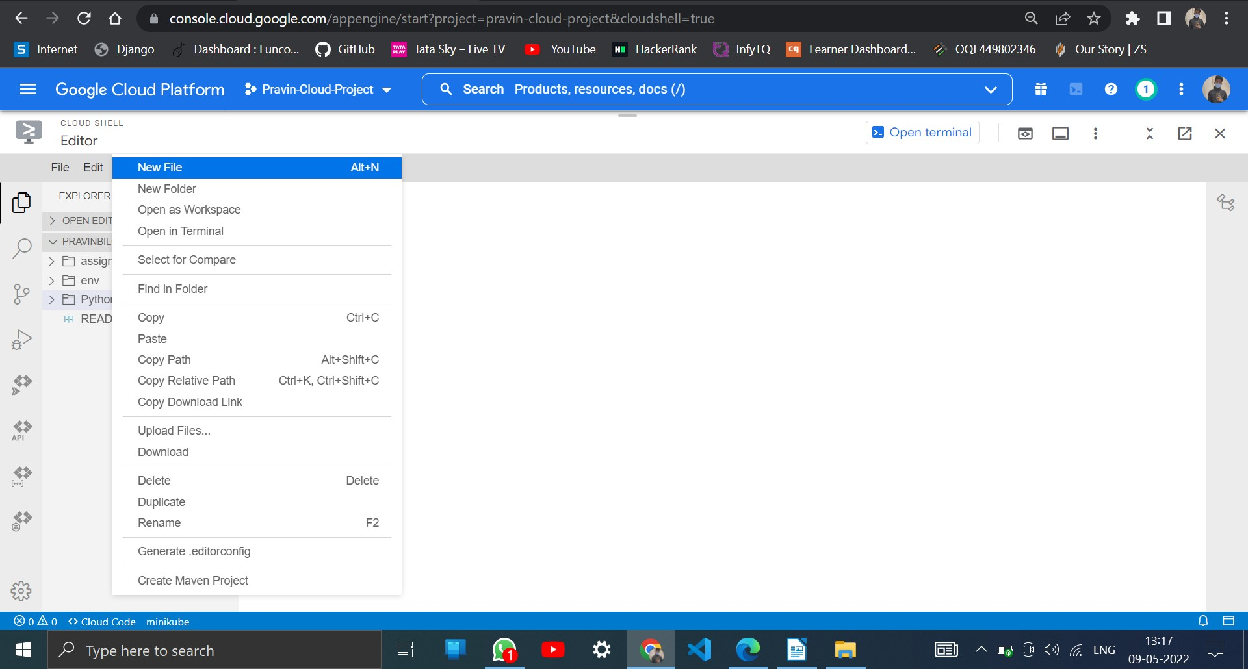

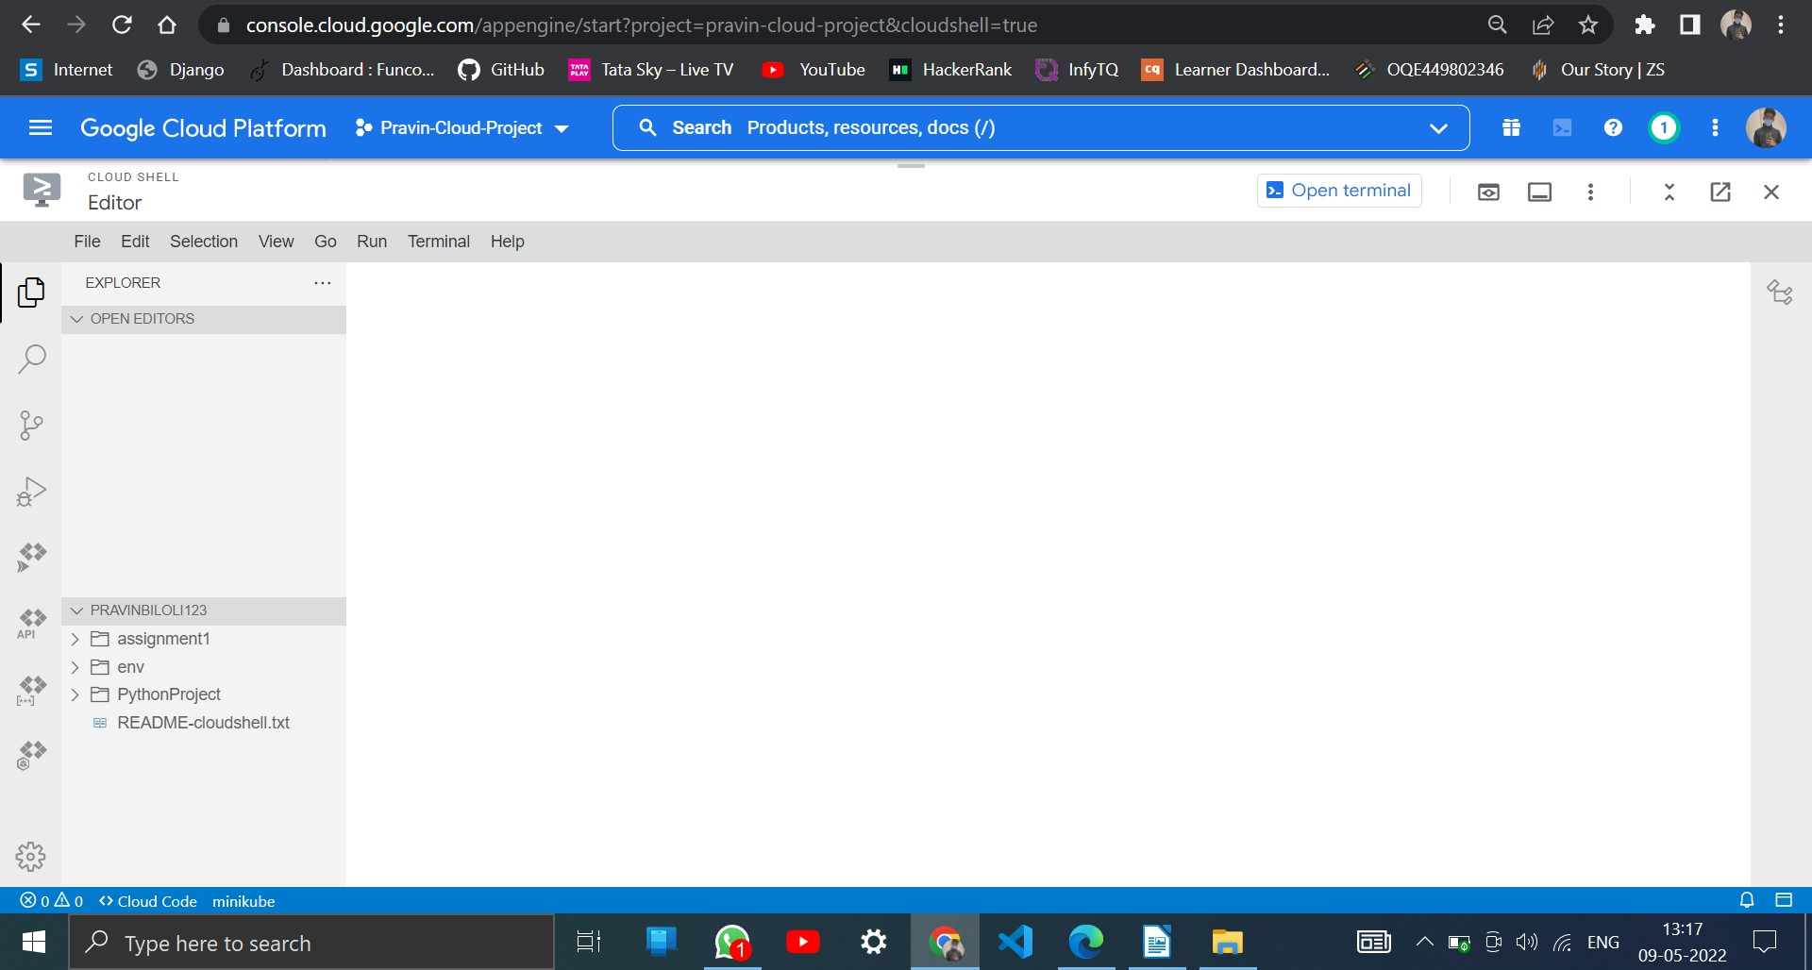

**Step 15 : Click New File in the PythonProject Folder (Python file)**

## Step 16 : Create main.py file

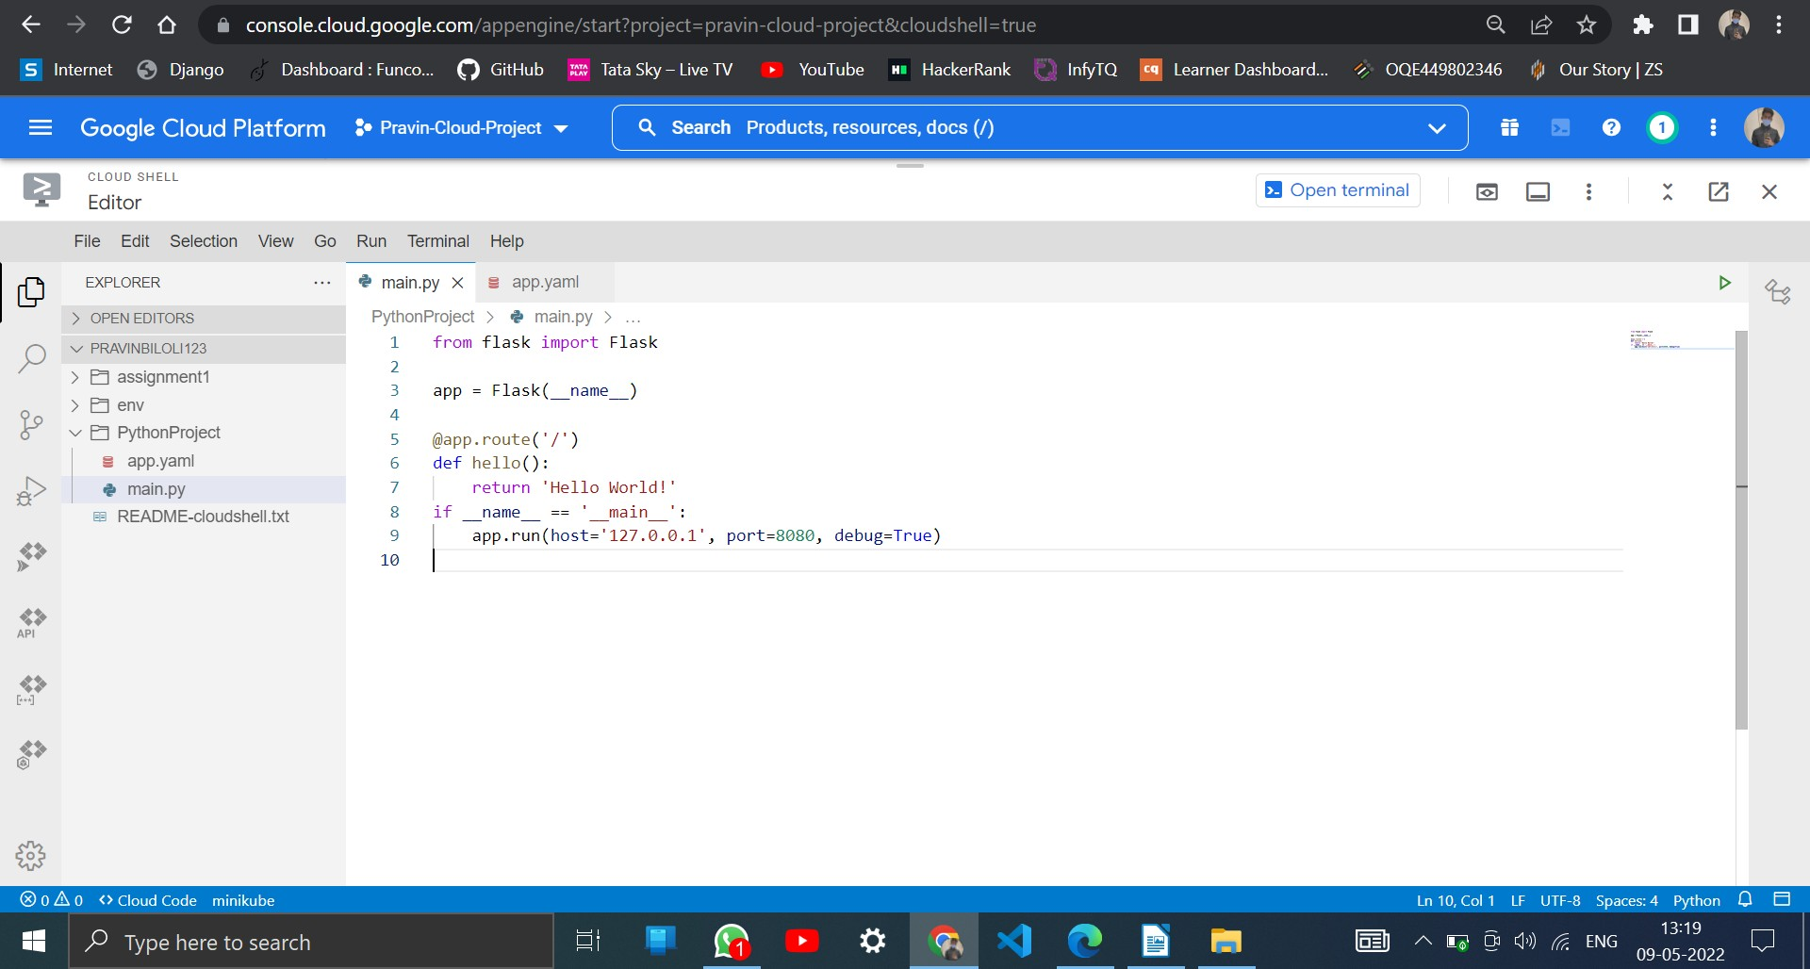

**main.py file**

import &nbsplogging

from &nbspflask import &nbspFlask app =&nbspFlask( name )

@app.route('/') def hello():

return 'Hello&nbspWorld'

if name == ' main ': &nbspapp.run(host='127.0.0.1',port=8080, debug=True)

## Step 17 : Create app.yaml file app.yaml

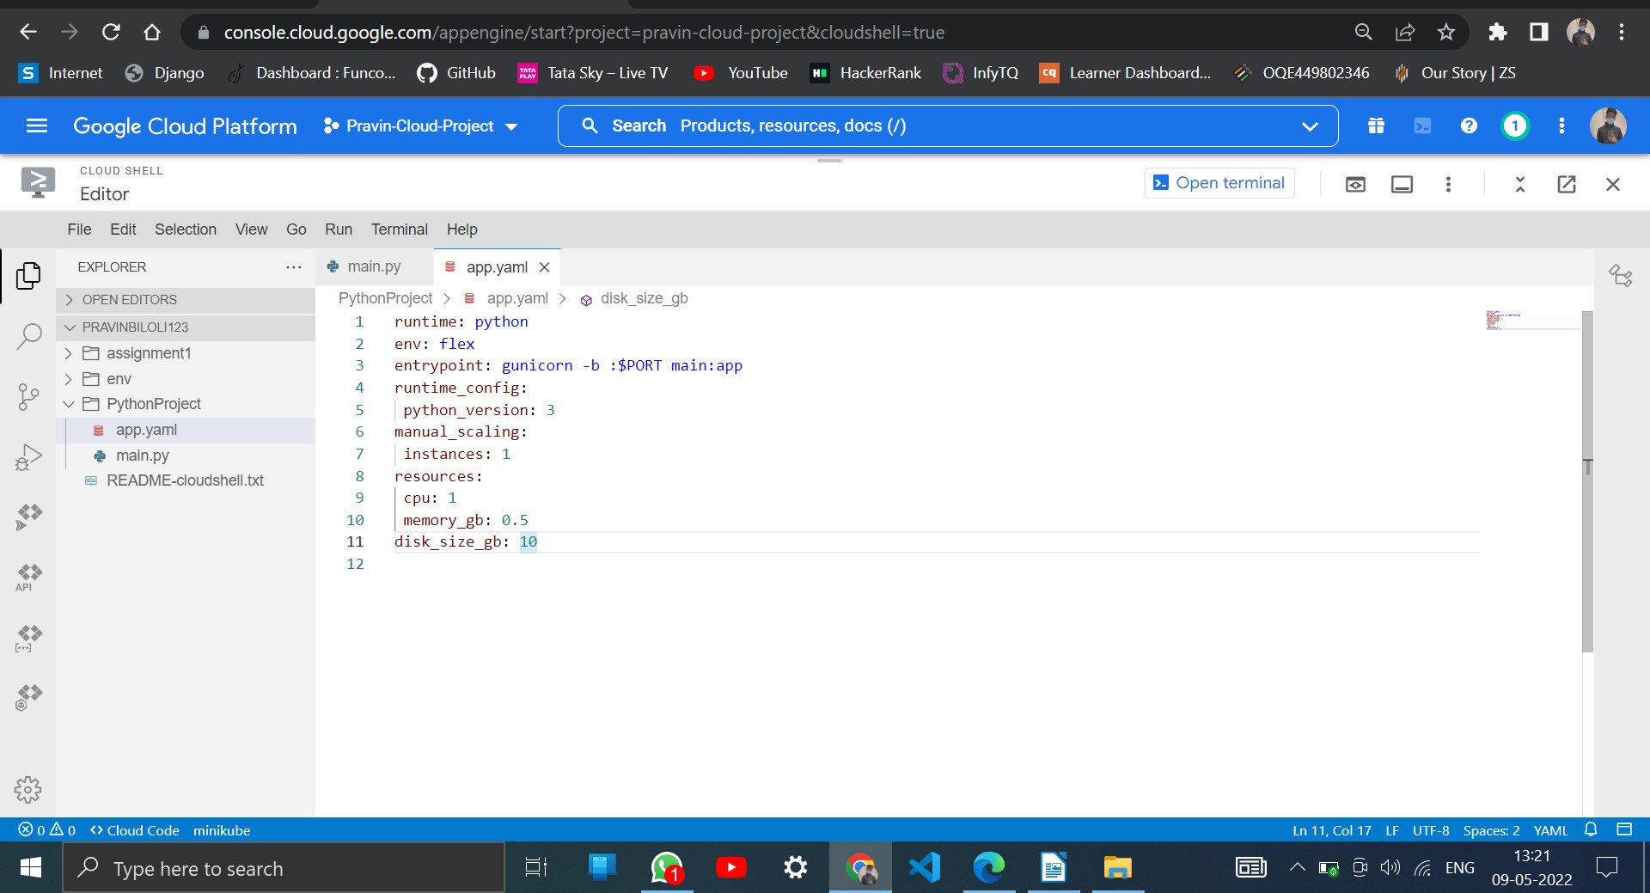

runtime: python env: flex

entrypoint: gunicorn -b :$PORT&nbspmain:app

runtime_config: python_version: 3

## Step 18 : Create requirements.txt file

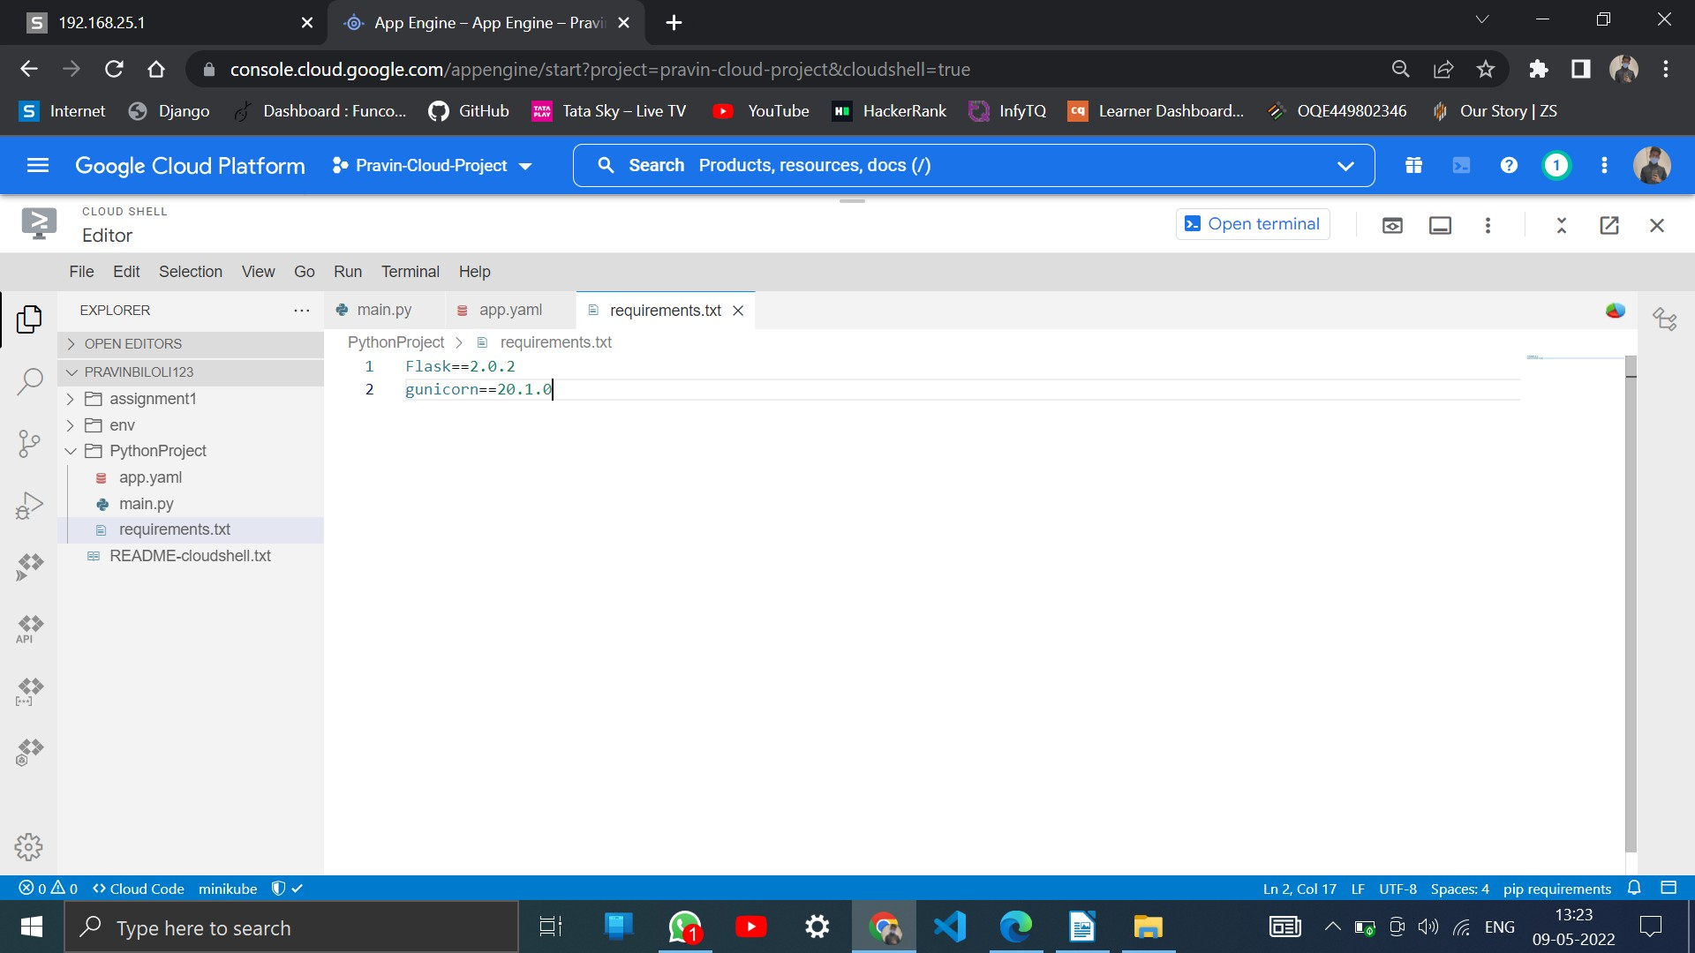

**requirements.txt**

Flask==0.11.1 gunicorn==19.6.0

## Step 19 : Move to Cloud Shell Environment to run the application

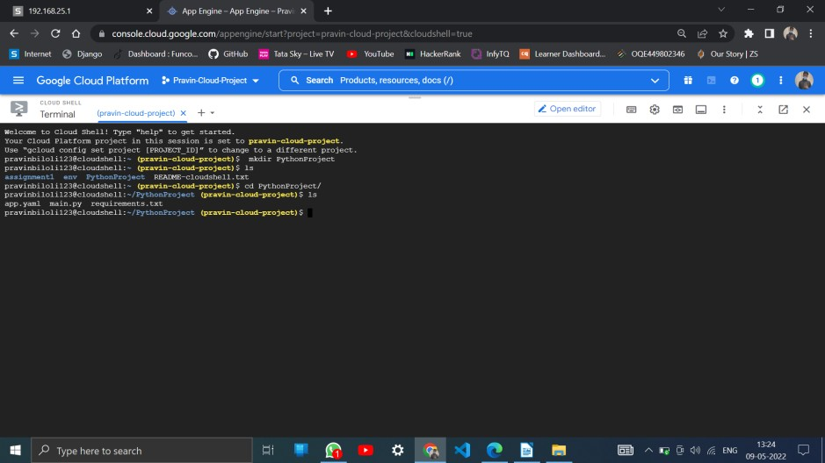

**Step 20 : Move to Cloud Shell Environment to run the**

## applicationSyntax: gcloud app deploy

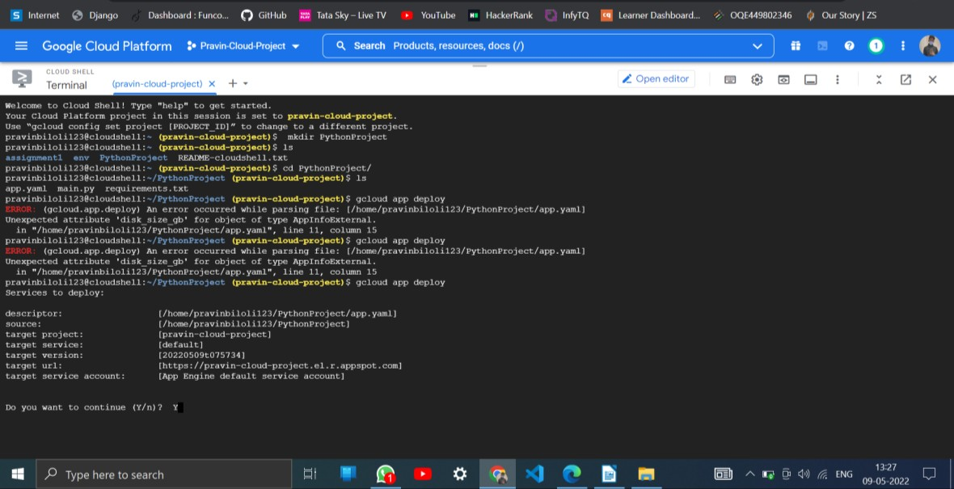

Continue the application. It enable service on the given project

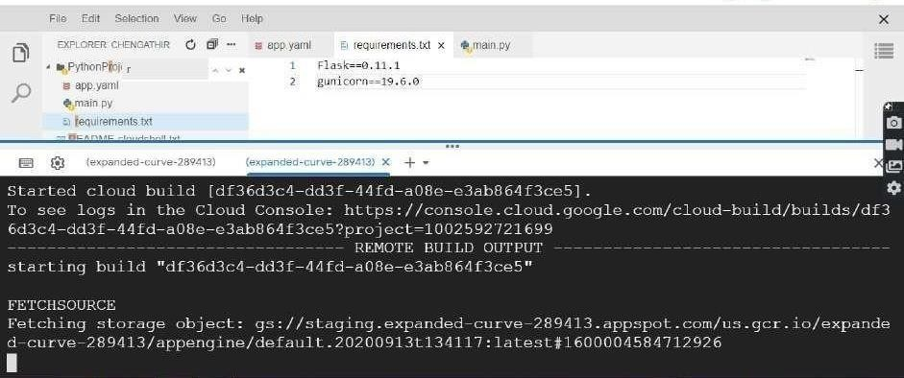

It started building the object and fetching the storage object for the created application

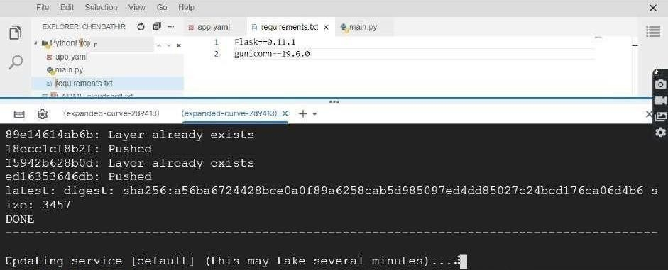

It is updating the service

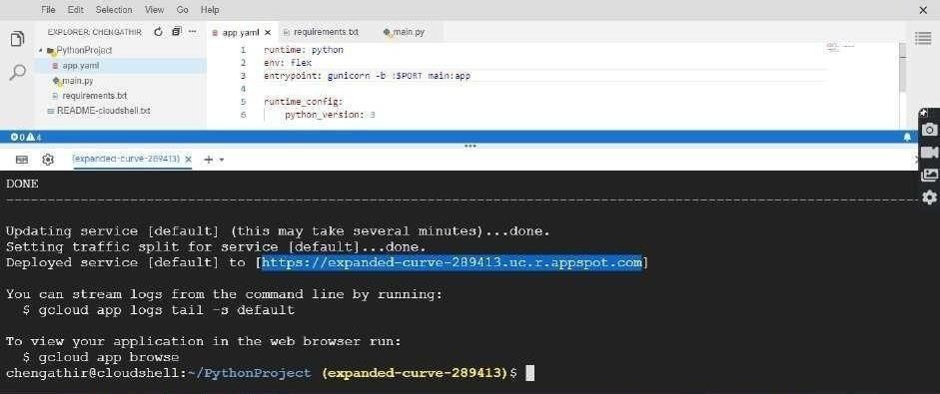

The application is successfully deployed and URL is https://expanded-curve-289413.uc.r.appspot.com

## Step 21 : Run your program in the broswer

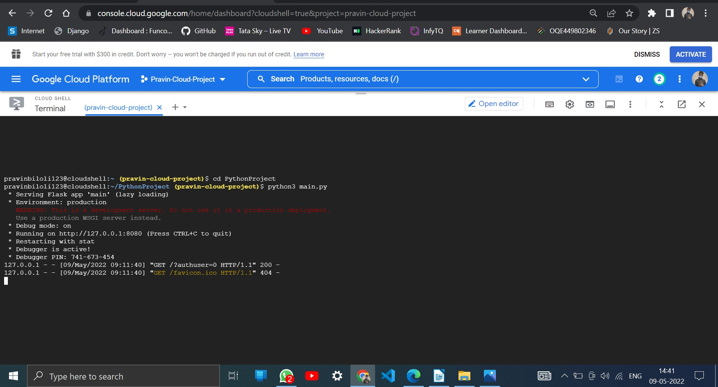

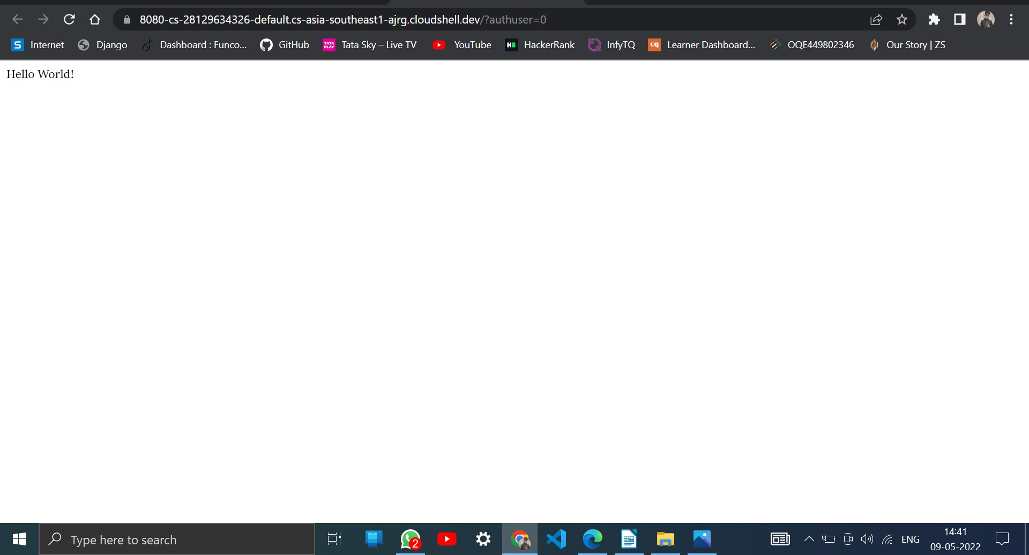

**Step 22 : Hello World Program is sucessfully run in the browser**

## Result:

Thus the Google App Engine is installed successfully and a web application to display hello world using python is developed and deployed in the GAE and used GAE Launcher to launch the web applications.

|  |  |
| --- | --- |
| **Ex No. 3 a** | **Simulate a cloud scenario using CloudSim** |

## Introduction:

 **CloudSim**

* A Framework for modeling and simulation of Cloud Computing Infrastructures and services
* Originally built at the Cloud Computing Distributed Systems (CLOUDS) Laboratory, The University of Melbourne, Australia
* It is completely written in JAVA

 **Main Features of CloudSiM** o Modeling and simulation

* + Data centre network topologies and message-passing applications o Dynamic insertion of simulation elements o Stop and resume of simulation
  + Policies for allocation of hosts and virtual machines

##  Cloudsim – Essentials

* JDK 1.6 or above <http://tinyurl.com/JNU-JAVA>
* Eclipse 4.2 or above <http://tinyurl.com/JNU-Eclipse>
* Alternatively NetBeans<https://netbeans.org/downloads>
* Up & Running with cloudsim guide: https://goo.gl/TPL7Zh

##  Cloudsim-Directory structure

* cloudsim/ -- top level CloudSim directory
* docs/ -- CloudSim API Documentation
* examples/ -- CloudSim examples
* jars/ -- CloudSim jar archives
* sources/ -- CloudSim source code

##  Cloudsim - Layered Architecture

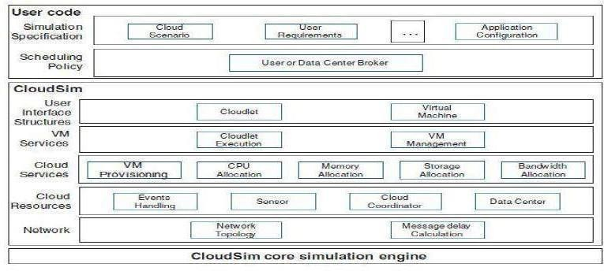

 **Cloudsim - Component model classes** o CloudInformationService.java o Datacenter.java,Host.java,Pe.java o Vm.java,Cloudlet.java o DatacenterBroker.java

* + Storage.java,HarddriveStorage.java, SanStorage.java

 **Cloudsim - Major blocks/Modules** o org.cloudbus.cloudsim o org.cloudbus.cloudsim.core o org.cloudbus.cloudsim.core.predicates o org.cloudbus.cloudsim.distributions o org.cloudbus.cloudsim.lists o org.cloudbus.cloudsim.network o org.cloudbus.cloudsim.network.datacenter o org.cloudbus.cloudsim.power o org.cloudbus.cloudsim.power.lists o org.cloudbus.cloudsim.power.models o org.cloudbus.cloudsim.provisioners

* + org.cloudbus.cloudsim.util

 **Cloudsim - key components** o Datacenter o DataCenterCharacteristics o Host o DatacenterBroker o RamProvisioner o BwProvisioner o Storage

* + Vm

o VMAllocationpolicy o VmScheduler o Cloudlet o CloudletScheduler o CloudInformationService o CloudSim o CloudSimTags o SimEvent o SimEntity o CloudsimShutdown o FutureQueue o DefferedQueue o Predicate and associative classes.

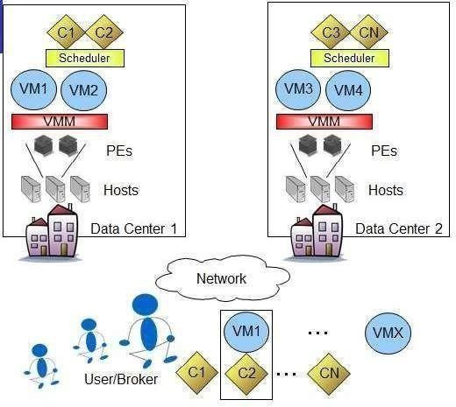

## CloudSim Elements/Components

**Procedure to import Eclipse, Cloudsim in your system**

**Step 1:** Link to download Eclipse and download Eclipse for Windows 64bit into your Local machine

[https://www.eclipse.org/downloads/packages/release/kepler/sr1/eclipse-ide-](https://www.eclipse.org/downloads/packages/release/kepler/sr1/eclipse-ide-java-developers) [java-developers](https://www.eclipse.org/downloads/packages/release/kepler/sr1/eclipse-ide-java-developers)

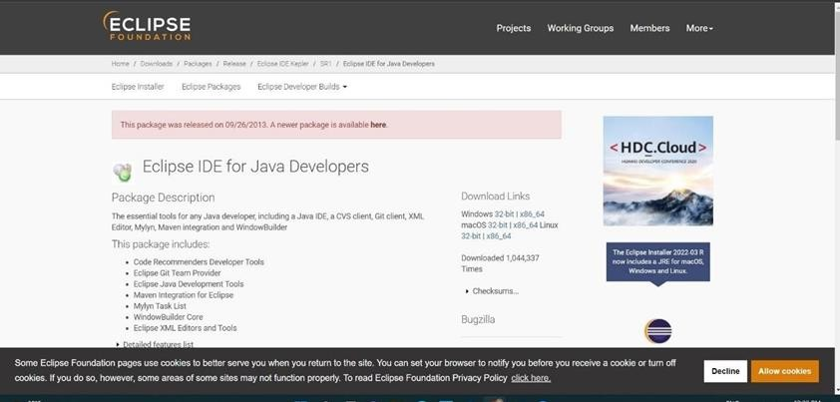

**Step 2:** Download cloudsim-3.0.3 from git hub repository in your local machine <https://github.com/Cloudslab/cloudsim/releases/tag/cloudsim-3.0.3>

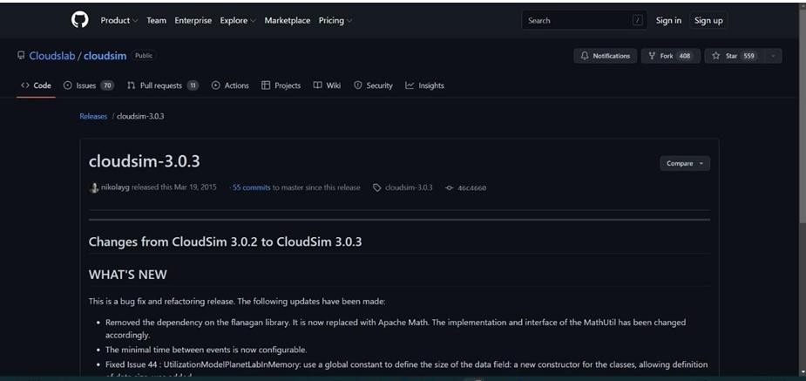

**Step 3:** Download commons-maths3-3.6.1 from git hub repository in your local machine<https://commons.apache.org/proper/commons-math/download_math.cgi>

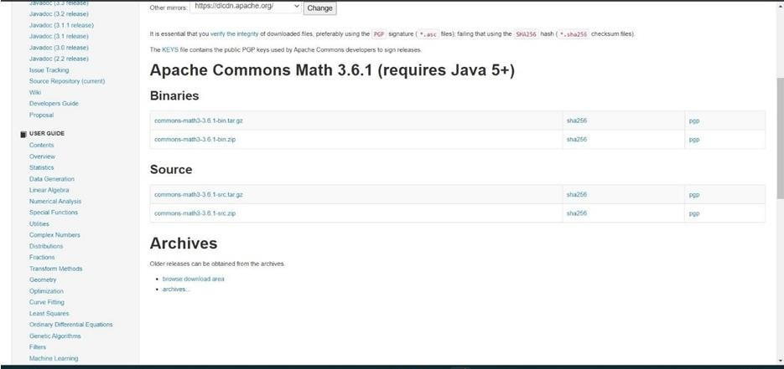

**Step 4:** Downloaded Eclipse, cloudsim-code-master and Apache Commons Math 3.6.1 in your local machine and extract cloudsim-3.0.3 and Apache Commons Math 3.6.1

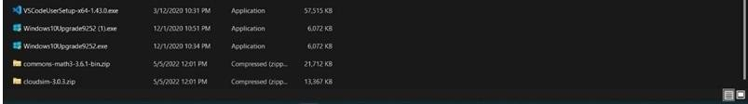

**Step 5:** First of all, navigate to the folder where you have unzipped the eclipse folder and open Eclipse.exe

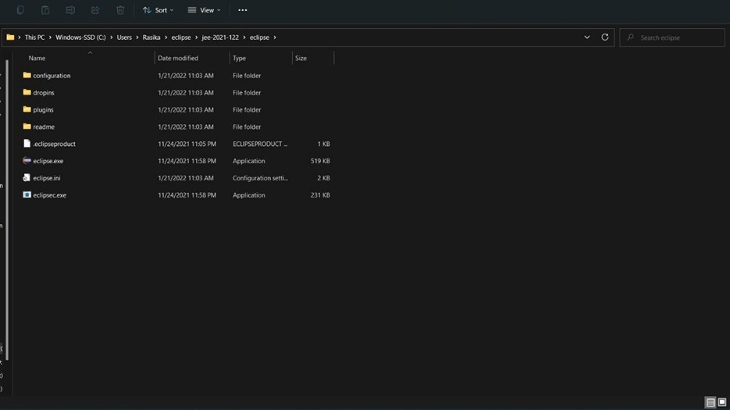

**Step 6:** Now within Eclipse window navigate the menu: *File -> New -> Project,* to open the new project wizard

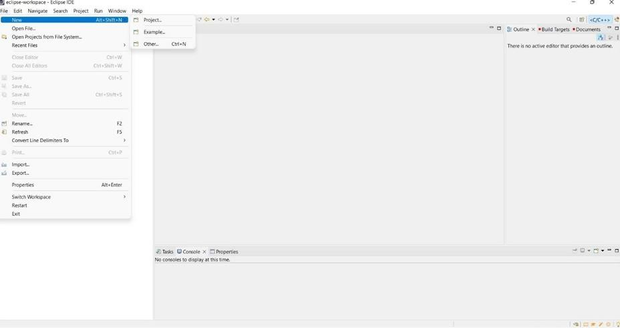

**Step 7:** A ‗*New Project*‗ wizard should open. There are a number of options displayed and you have to find & select the ‗*Java Project*‗ option, once done click *‘Next*‗

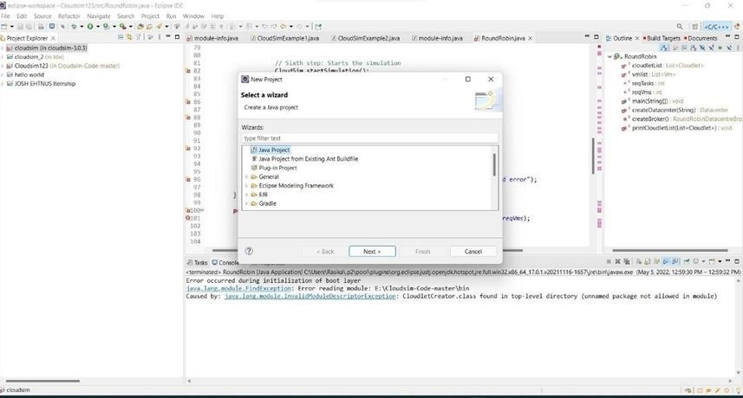

**Step 8:** Now a detailed new project window will open, here you will provide the project name and the path of CloudSim project source code, which will be done as follows:

## Project Name: CloudSim.

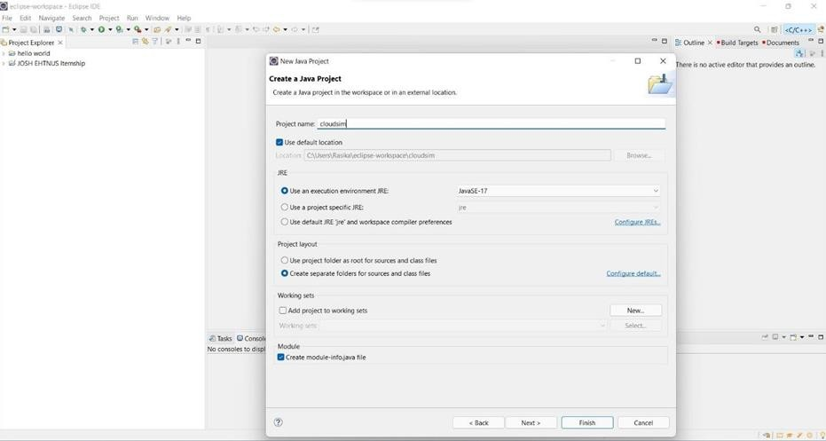

**Step 9:** Unselect the *‘Use default location’* option and then click on *‘Browse’* to open the path where you have unzipped the Cloudsim project and finally click Next to set project settings.

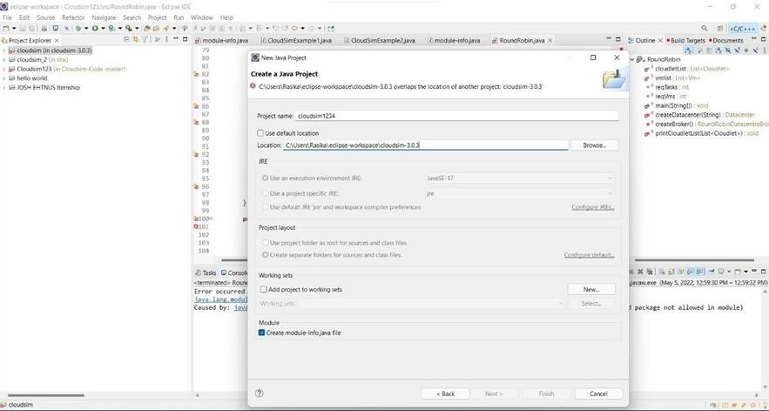

**Step 10:** Make sure you navigate the path till you can see the bin, docs, examplesetc folder in the navigation plane.

**Step 11:** Once done finally, click ‗Next‘ to go to the next step i.e. setting up of project settings

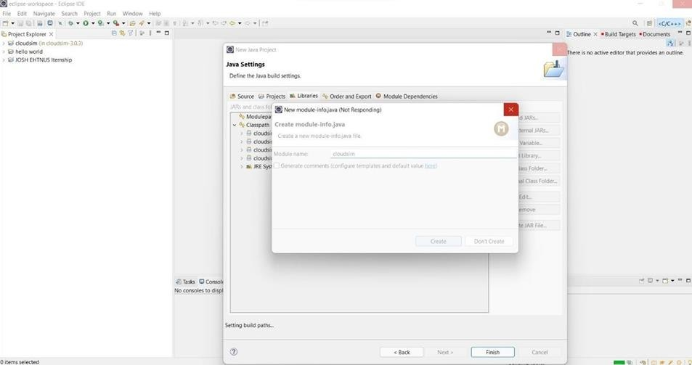

**Step 12:** Now open *‘Libraries’* tab and if you do not find commons-math3-3.x.jar *(here ‘x’ means the minor version release of the library which could be 2 or greater*) in the list then simply click on ‗*Add External Jar’* (commons-math3-3.x.jar will be included in the project from this step)

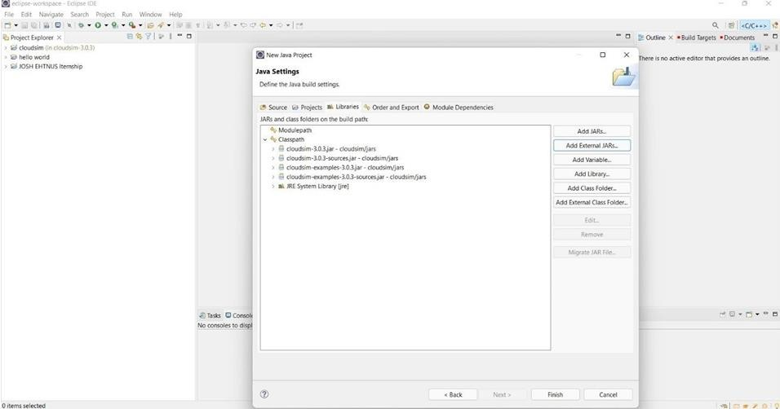

**Step 13:** Once you have clicked on ‗*Add External JAR’s*‗ Open the path where you have unzipped the commons-math binaries and select ‗*Commons-math3-3.x.jar*‘ and click on open.

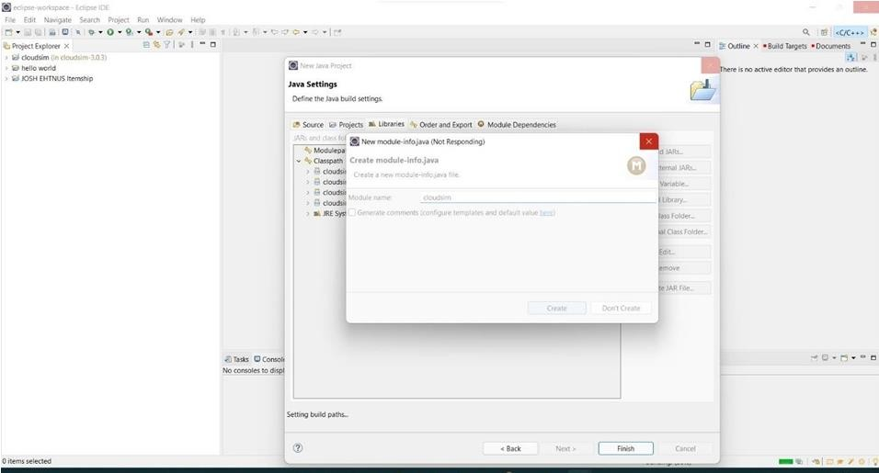

**Step 14:** Ensure external jar that you opened in the previous step is displayed in the list and then click on ‗*Finish*‘ (your system may take 2-3 minutes to configure the project)

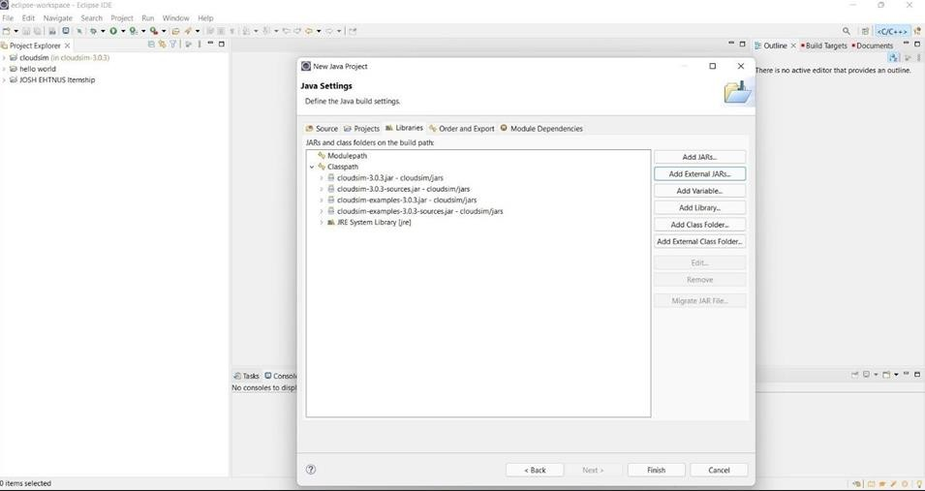

**Step 15:** Once the project is configured you can open the ‗*Project Explorer*‗and start exploring the Cloudsim project. Also for the first time eclipse automatically start building the workspace for newly configured Cloudsim project, which may take some time depending on the configuration of the computer system.

Following is the final screen which you will see after Cloudsim is configured.

**Step 16:** Now just to check you within the ‗**Project Explorer**‗, you should navigate to the

‗**examples**‗ folder, then expand the package ‗*org.cloudbus.cloudsim.examples*‗ and double click to open the ‗*CloudsimExample1.java*‗

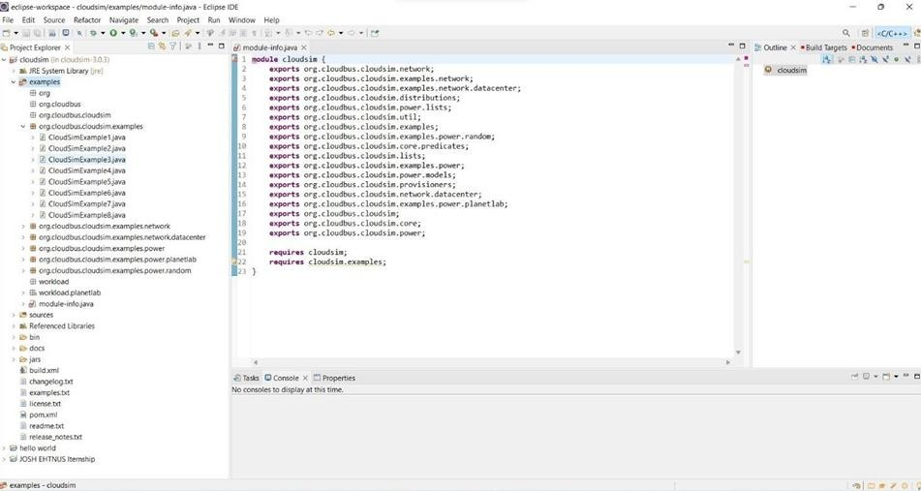

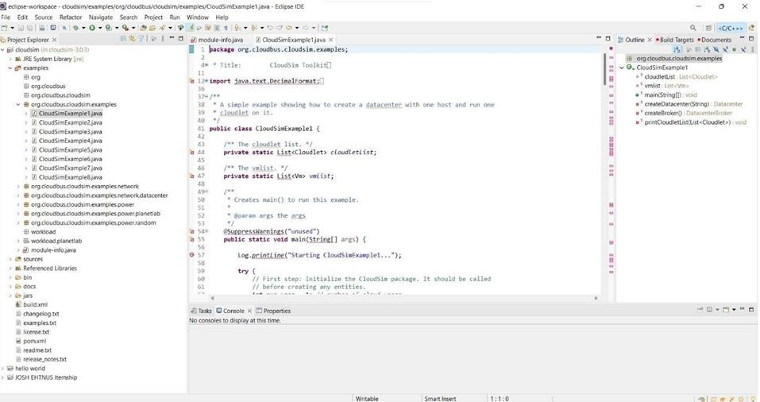

.

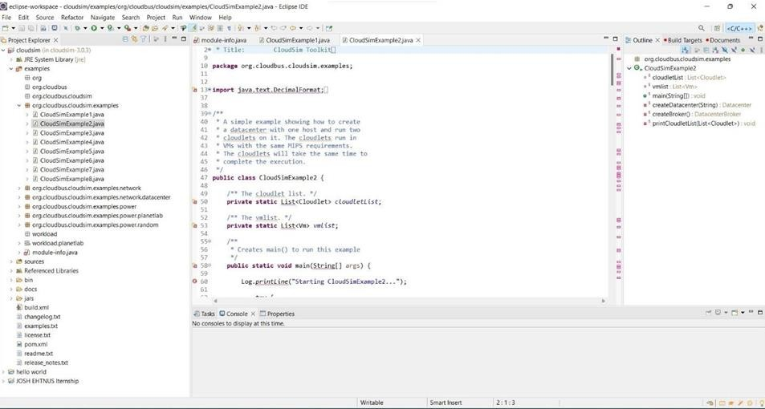

**Step 17:** Now navigate to the Eclipse menu ‗*Run ->Run*‗ or directly use a keyboard shortcut

*‘Ctrl + F11’* to execute the ‗*CloudsimExample1.java*‗.

**Step 18:** If it is successfully executed it should be displaying the following type to output in the console window of the Eclipse IDE.

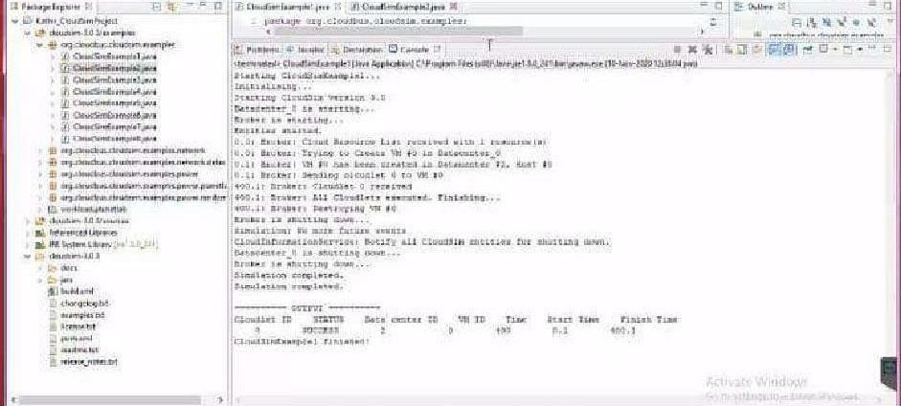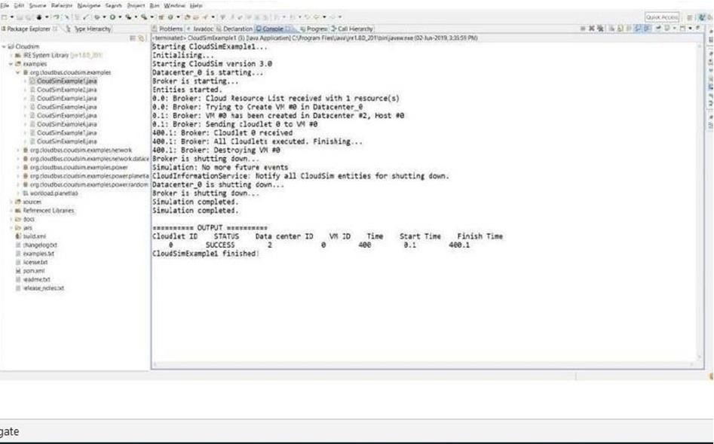

## Result:

Thus the cloudsim is simulated using Eclipse Environment successfully.

|  |  |
| --- | --- |
| **Ex No. 3 b** | **Simulate a cloud scenario using CloudSim and running a scheduling algorithm** |

## Procedure to import Eclipse, running scheduling algorithms in your system

**Step 1:** Link to download Eclipse and download Eclipse for Windows 64bit into your Local machine

[https://www.eclipse.org/downloads/packages/release/kepler/sr1/eclipse-ide-](https://www.eclipse.org/downloads/packages/release/kepler/sr1/eclipse-ide-java-developers) [java-developers](https://www.eclipse.org/downloads/packages/release/kepler/sr1/eclipse-ide-java-developers)

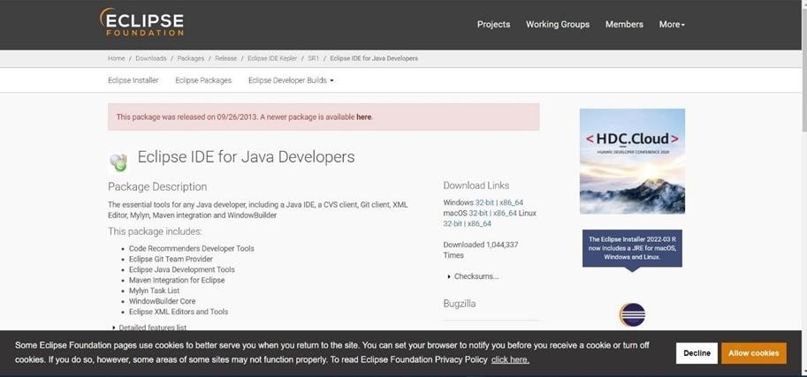

**Step 2:** Download scheduling source code **cloudsim-code-master** from git hub repository in your local machine

<https://github.com/shiro873/Cloudsim-Code>

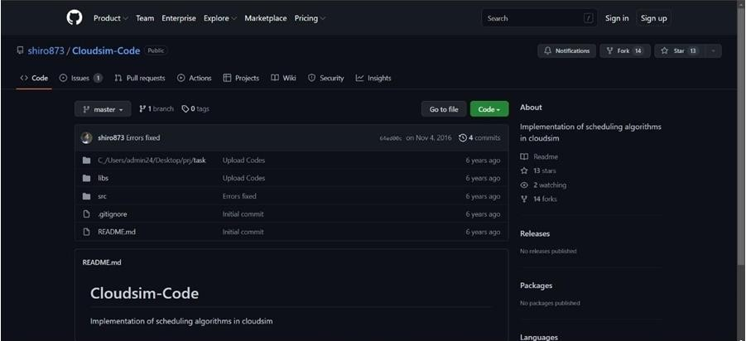

**Step 3:** Download commons-maths3-3.6.1 from git hub repository in your local machine

<https://commons.apache.org/proper/commons-math/download_math.cgi>

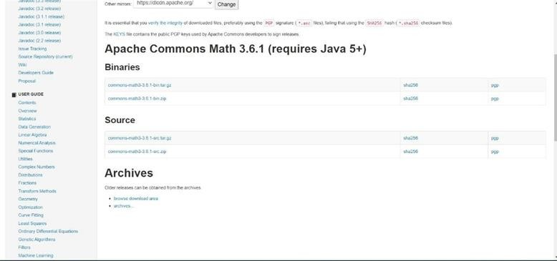

**Step 4:** Downloaded Eclipse, cloudsim-3.0.3 and Apache Commons Math 3.6.1 in your local machine and extract cloudsim-3.0.3 and Apache Commons Math 3.6.1

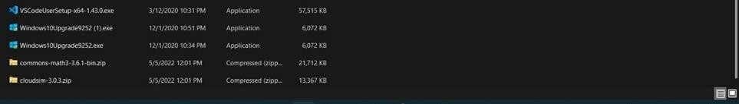

**Step 5:** First of all, navigate to the folder where you have unzipped the eclipse folder and open Eclipse.exe

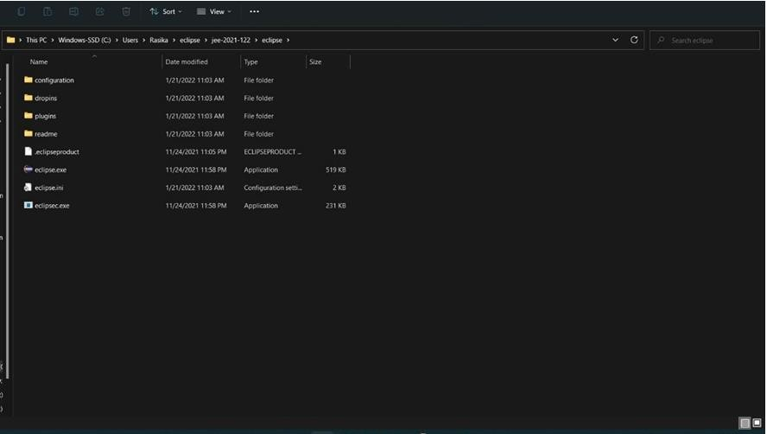

**Step 6:** Now within Eclipse window navigate the menu: *File -> New -> Project,* to open the new project wizard

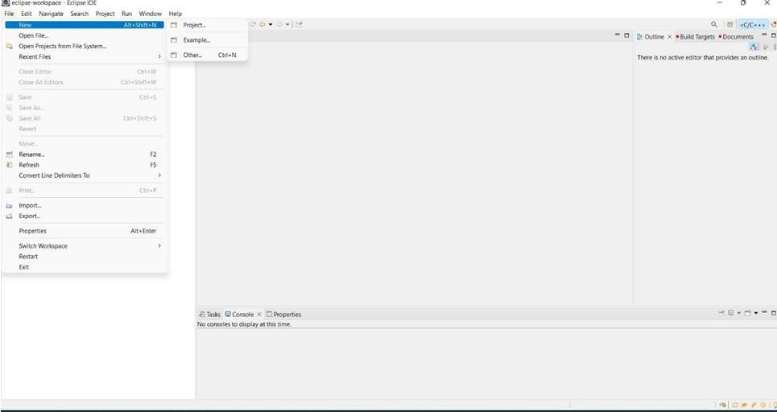

**Step 7:** A ‗*New Project*‗ wizard should open. There are a number of options displayed and you have to find & select the ‗*Java Project*‗ option, once done click *‘Next*‗

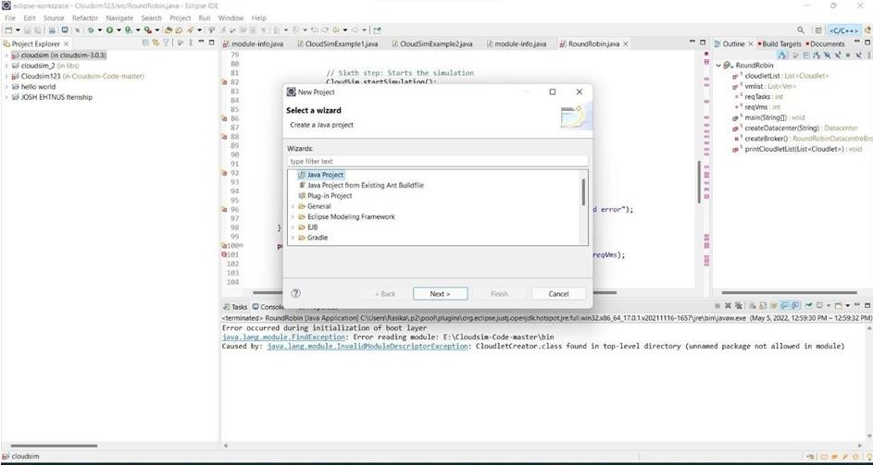

**Step 8:** Now a detailed new project window will open, here you will provide the project name and the path of CloudSim-master-code project source code, which will be done as follows:

## Project Name: CloudSim

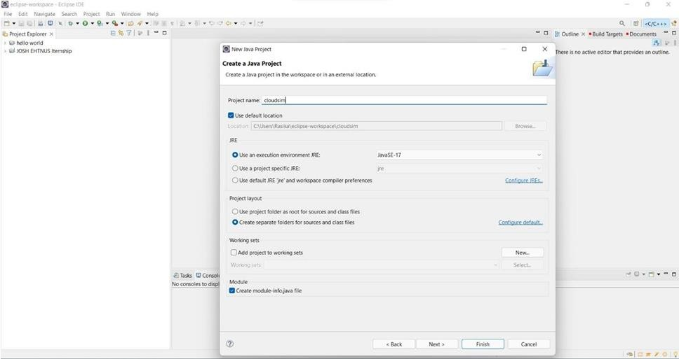

**Step 9:** Unselect the *‘Use default location’* option and then click on *‘Browse’* to open the path where you have unzipped the Cloudsim-code-master project and finally click Next to set project settings.

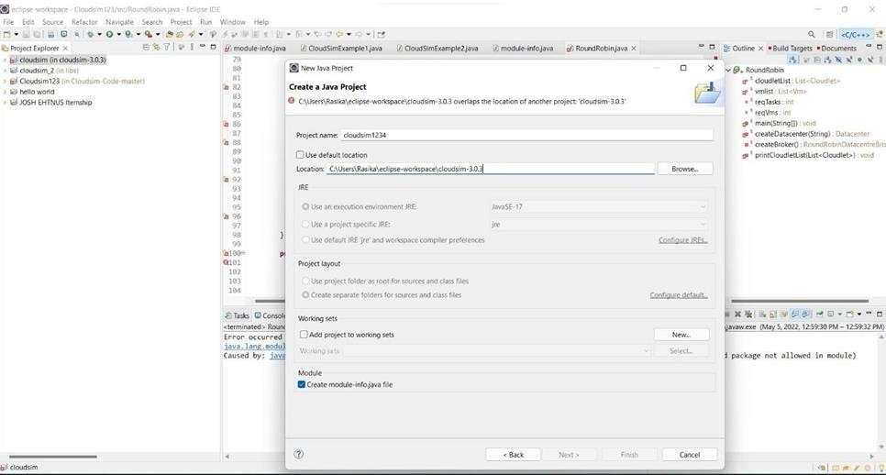

**Step 10:** Make sure you navigate the path till you can see the bin, docs, examplesetc folder in the navigation plane.

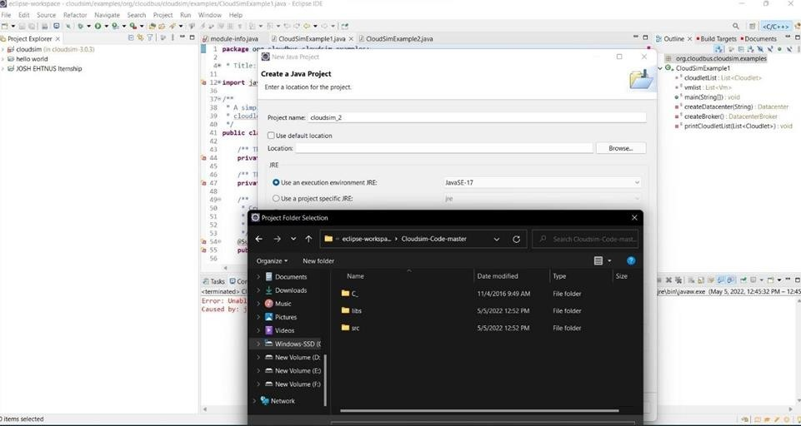

**Step 11:** Once done finally, click ‗Next‘ to go to the next step i.e. setting up of project settings

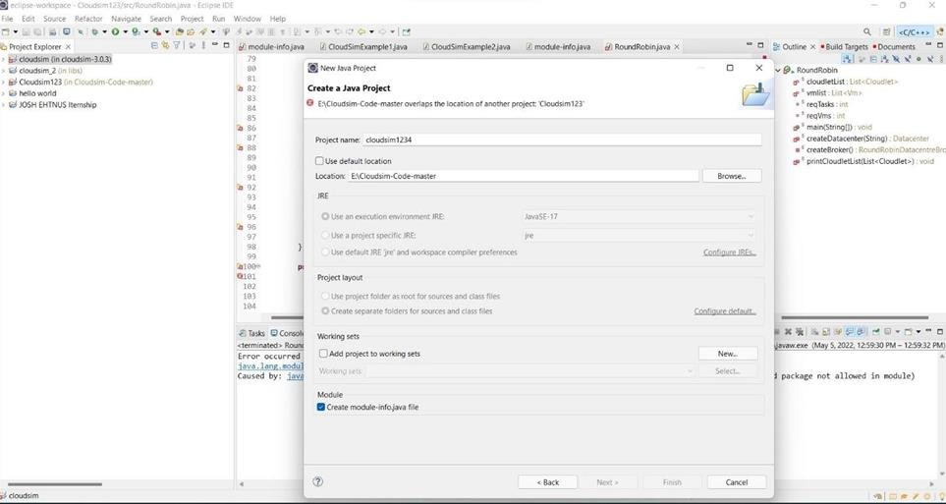

**Step 12:** Once the project is configured you can open the ‗*Project Explorer*‗ and start exploring the Cloudsim project. Also for the first time eclipse automatically start building the workspace for newly configured Cloudsim project, which may take some time depending on the configuration of the computer system.

Following is the final screen which you will see after Cloudsim is configured.

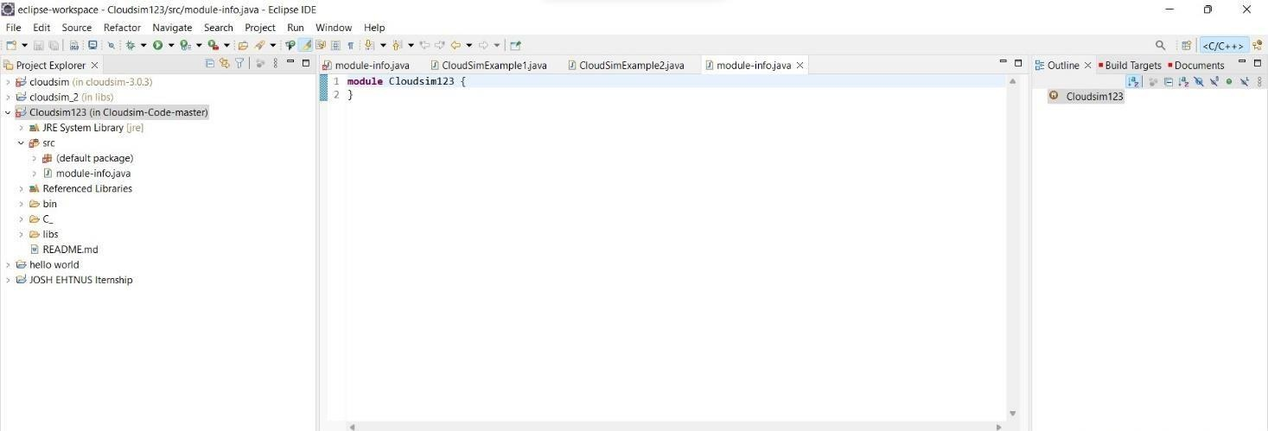

**Step 13:** Now just to check you within the ‗**Project Explorer**‗, you should navigate to the

‗**src**‗ folder, then expand the package ‗*default package*‗ and double click to open the

‗R*oundRobin.java*‗.

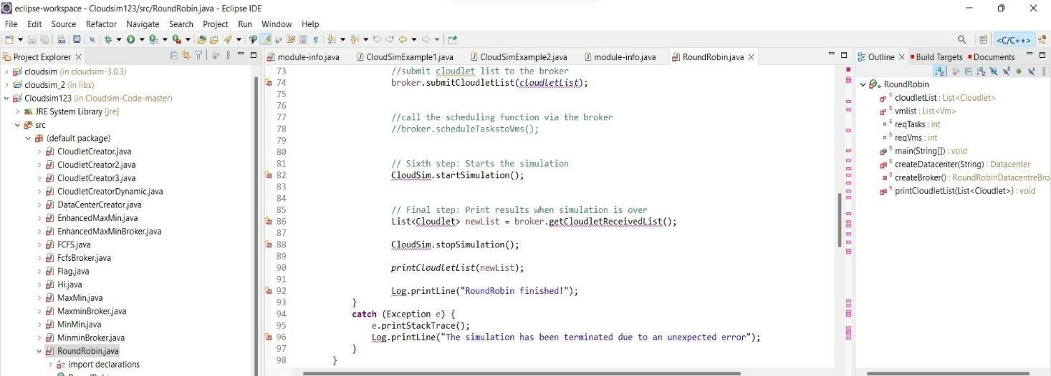

**Step 14:** Now navigate to the Eclipse menu ‗*Run ->Run*‗ or directly use a keyboard shortcut *‘Ctrl + F11’* to execute the *‘RoundRobin*.java‘. If it is successfully executed it should be displaying the following type to output in the console window of the Eclipse IDE.

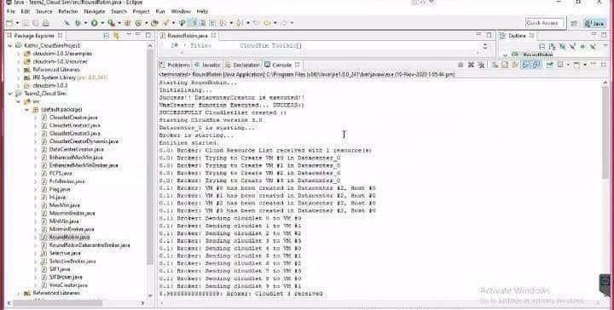

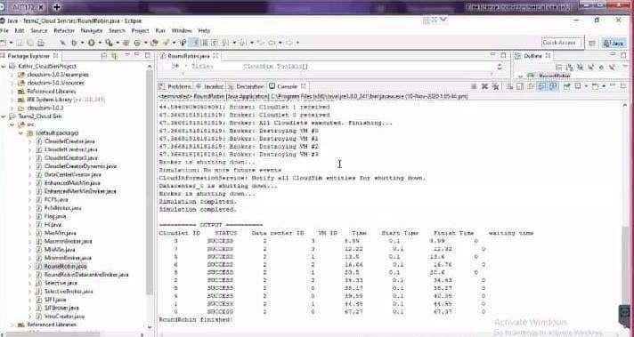

## Result:

Thus the scheduling algorithm is executed in cloudsim is simulated using Eclipse Environment successfully.

|  |  |
| --- | --- |
| **Ex No. 4** | **Procedure File Transfer in Client & Server using virtual machine.** |

# Aim:

To procedure File Transfer in Client & Server using virtual machine

**Steps:** Steps to perform File Transfer in Client & Server using virtual machine.

Step 1: Open a virtual machine to do file transfer.

Step 2: Write the java program for FTP Client and FTP Server. Step 3: Run the program.

# Source Code:

**FTPClient.java**

import java.io.*; import java.net.*; import java.util.*; public class FTPClient{ public static void main(String args[])throws IOException { try { int number;

Socket s=new Socket("127.0.0.1",10087); Scanner sc=new Scanner(System.in); System.out.println("Enter the file name:"); String fn=sc.next();

DataOutputStream dos=new DataOutputStream(s.getOutputStream()); dos.writeUTF(fn);

DataInputStream dis=new DataInputStream(s.getInputStream()); String input=(String)dis.readUTF();

FileInputStream fis=new FileInputStream(input); System.out.println("Even Numbers in the" +fn+" are"); int i=0;

while((i=fis.read())!=-1){ System.out.println((char)i);

}

s.close(); } catch(Exception e){

System.out.println("Port not available "+e); }

}

}

# FTPServer.java

import java.io.*; import java.net.*; import java.util.*; public class FTPServer{ public static void main(String args[])throws IOException{ try{ int num;

Scanner sc=new Scanner(System.in); ServerSocket ss=new ServerSocket(10087); Socket s=ss.accept(); System.out.println("Waiting. ");

DataInputStream dis=new DataInputStream(s.getInputStream()); String input=(String)dis.readUTF();

DataOutputStream dos=new DataOutputStream(s.getOutputStream()); FileInputStream fis = new FileInputStream("out.txt"); FileOutputStream fos = new

FileOutputStream(input); while((num=fis.read())!= -

1) { if(num%2==0) { fos.write(num);

}

}

dos.writeUTF(input);

System.out.println("File is sent to client"); ss.close(); s.close(); } catch(Exception e) {

System.out.println("Port not available"+e); }

}

}

# Out.txt

1 2

3

4 5

6

7 8

9

# Output:

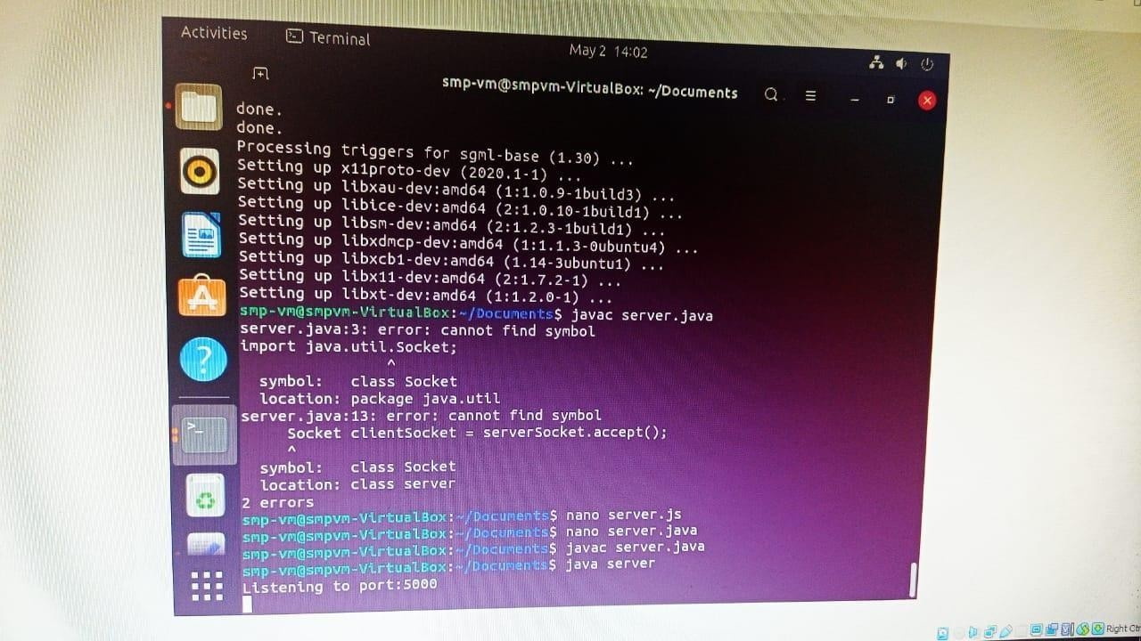

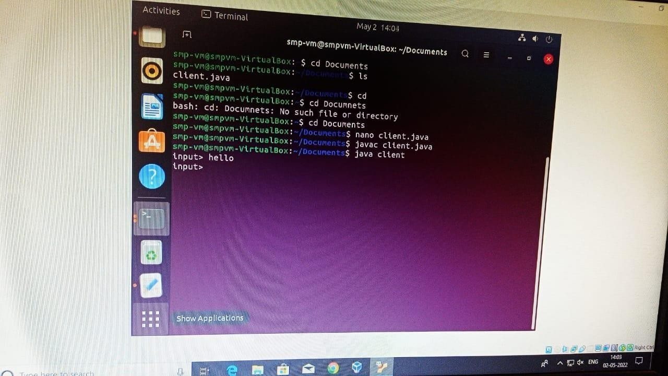

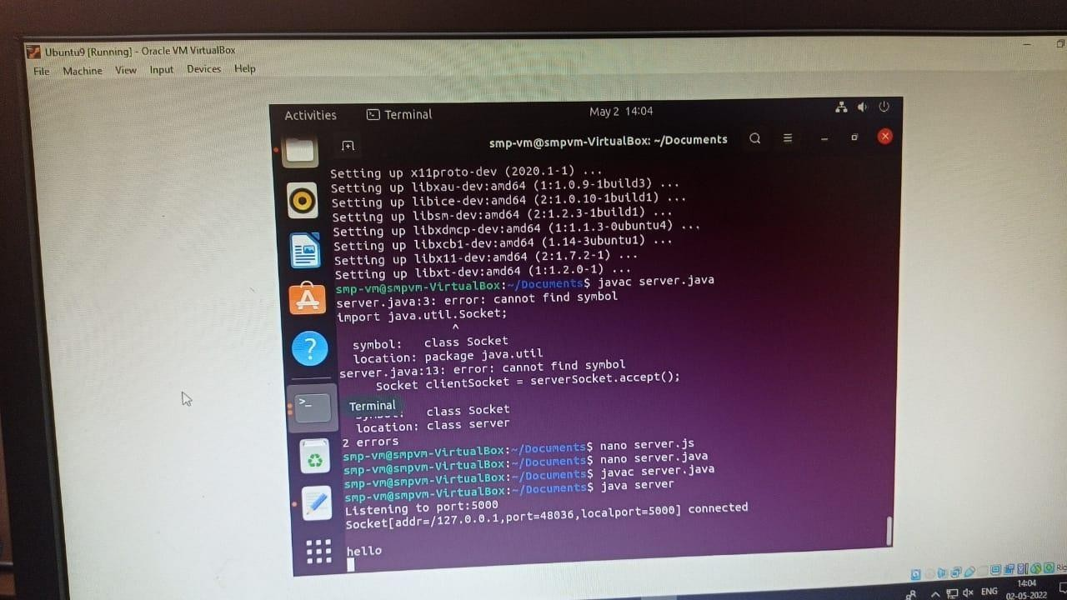

**Result:**

Thus the program to the File transfer operation using virtual machine was successfully executed and verified.

|  |  |
| --- | --- |
| **Ex No. 5** | **Find a procedure to launch virtual machine using Openstack** |

## Introduction:

 OpenStack was introduced by Rackspace and NASA in July 2010.

 OpenStack is an Infrastructure as a Service known as Cloud Operating System, that take resources such as Compute, Storage, Network and Virtualization Technologies and control those resources at a data center level

 The project is building an open source community - to share resources and technologies with the goal of creating a massively scalable and secure cloud infrastructure.

 The software is open source and limited to just open source APIs such as Amazon.

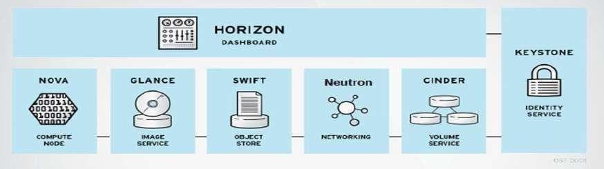The following figure shows the OpenStack architecture

OpenStack architecture

* It is modular architecture
* Designed to easily scale out
* Based on (growing) set of core services **The major components are**

## Keystone

1. **Nova**

## Glance

1. **Swift**

## Quantum

1. **Cinder**

## KEYSTONE :

* + - Identity service o Common authorization framework

o Manage users, tenants and roles

* + - Pluggable backends (SQL,PAM,LDAP, IDM etc)

## NOVA

* + - Core compute service comprised of
      * Compute Nodes – hypervisors that run virtual machines
        + Supports multiple hypervisors KVM,Xen,LXC,Hyper-V and ESX
      * Distributed controllers that handle scheduling, API calls, etc
* Native OpenStack API and Amazon EC2 compatible API

## GLANCE

* + - Image service o Stores and retrieves disk images (Virtual machine templates) o Supports RAW,QCOW,VHD,ISO,OVF & AMI/AKI
    - Backend Storage : File System, Swift, Gluster, Amazon S3

## SWIFT

* + - Object Storage service o Modeled after Amazon‘s Service
    - Provides simple service for storing and retrieving arbitrary data o Native API and S3 compatible API

## NEUTRON

* + - Network service
    - Provides framework for Software Defined Network o Plugin architecture
      * Allows intergration of hardware and software based network solutions
* Open vSwitch, Cisco UCS,Standard Linux Bridge,NiCira NVP

## CINDER

* + - Block Storage (Volume) service o Provides block storage for Virtual machines(persistent disks) o Similar to Amazon EBS service o Plugin architecture for vendor extensions
      * NetApp driver for cinder

## HORIZON

* + - Dashboard
    - Provides simple self service UI for end-users o Basic cloud administrator functions
      * Define users, tenants and quotas
* No infrastructure management

## HEAT OpenStack Orchestration

* + - Provides template driven cloud application orchestration o Modeled after AWS Cloud Formation o Targeted to provide advanced functionality such as high availability and auto scaling
    - Introduced by Redhat
  + **CEILOMETER –** OpenStack Monitoring and Metering o Goal: To Provide a single infrastructure to collect measurements from an entire OpenStack Infrastructure; Eliminate need for multiple agents attaching to multiple OpenStack Projects o Primary targets metering and monitoring: Provided extensibility

##  Steps in Installing Openstack Step 1:

* Download and Install Oracle Virtual Box latest version & Extension package

o <https://virtualbox.org/wiki/downloads>

## Step 2:

* + Download CentOS 7 OVA(Open Virtual Appliance) from o Link

: <https://linuxvmimages.com/images/centos-7>

* + Import CentOS 7 OVA(Open Virtual Appliance) into Oracle Virtual Box

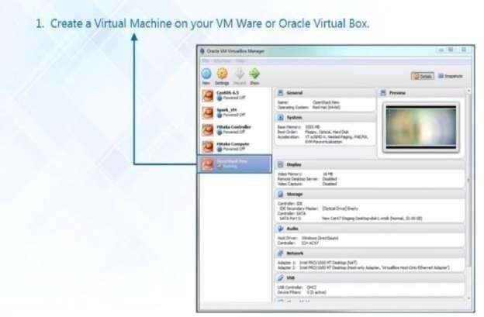

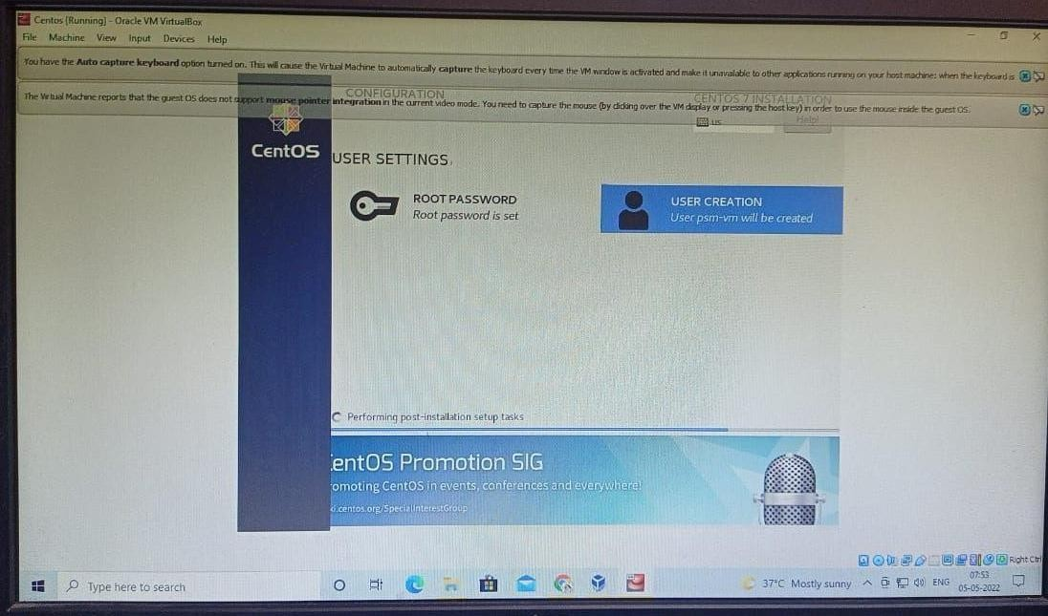

**Step 3:**Login into CenOS 7

* Login Details o **User name : centos** o **Password : centos**
* To change into root user in Terminal

## #sudosu–



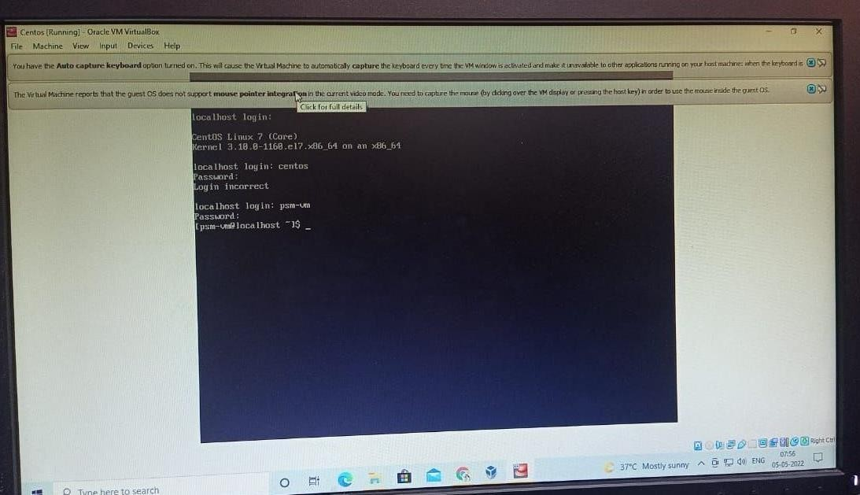

**Step 4**: Installation Steps for OpenStack

**Step5:** Command to disable and stop firewall

## # systemctl disable firewalld #systemctl stop firewalld

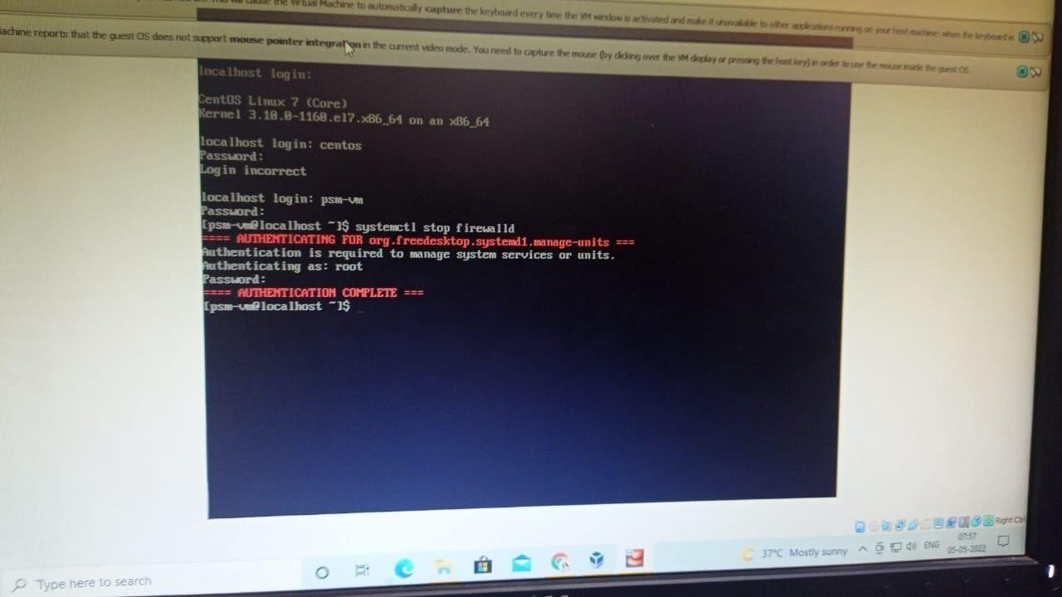

**Step 6:** Command to disable and stop Network Manager

## # systemctl disable NetworkManager # systemctl stop NetworkManager

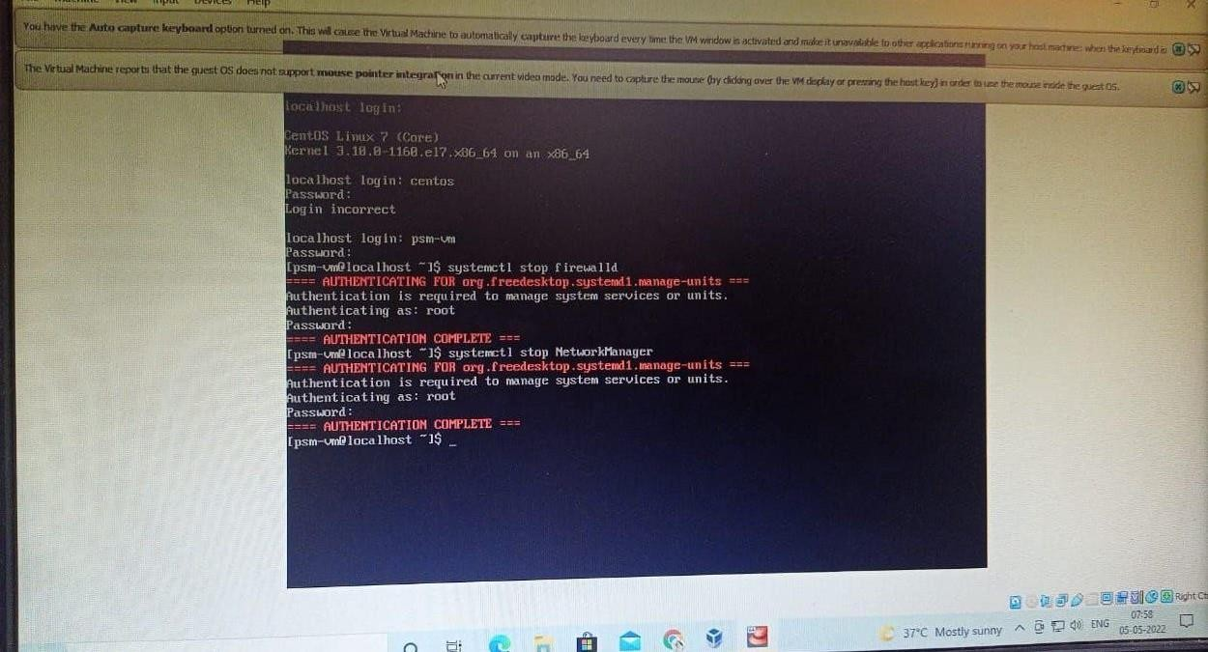

**Step 7:** Enable and start Network

## #systemctl enable network #systemctl start network

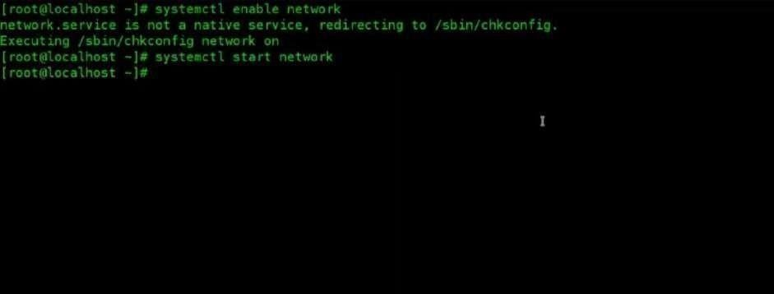

**Step 8: OpenStack** will be deployed on your Node with the help of **PackStack** package provided by **rdo** repository (**RPM Distribution of OpenStack**).In order to enable **rdo** repositories on Centos **7** run the below command.

**#yum install -y** [**https://rdoproject.org/repos/rdo-release.rpm**](https://rdoproject.org/repos/rdo-release.rpm)

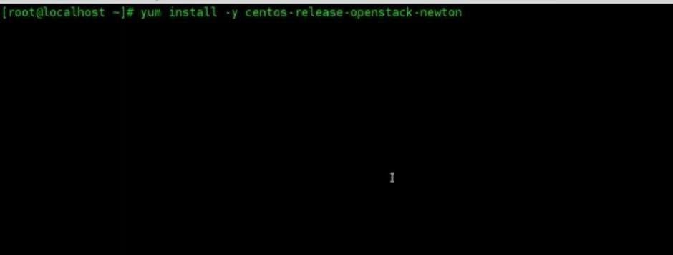

**Step 9:** Update Current packages

## #yum update –y

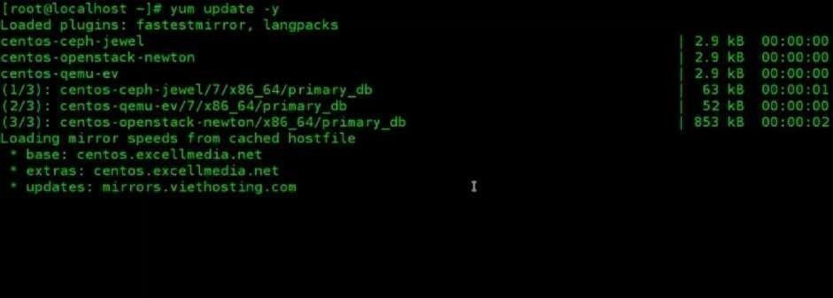

**Step 10:**Install OpenStack Release for CentOS

## #yum install –y openstack-packstack

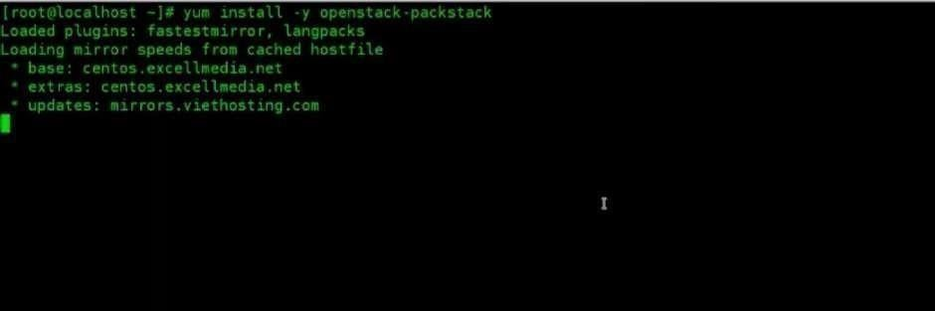

**Step 11:**Start packstack to install OpenStack Newton

## #packstak --allinone



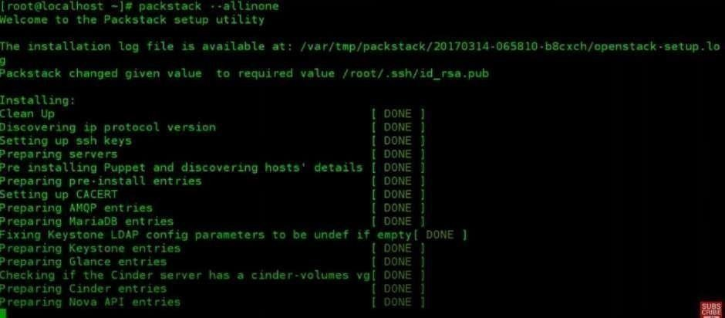

**Step 12:**Note the user name and password from keystonerc_admin

## #cat keystonerc_admin

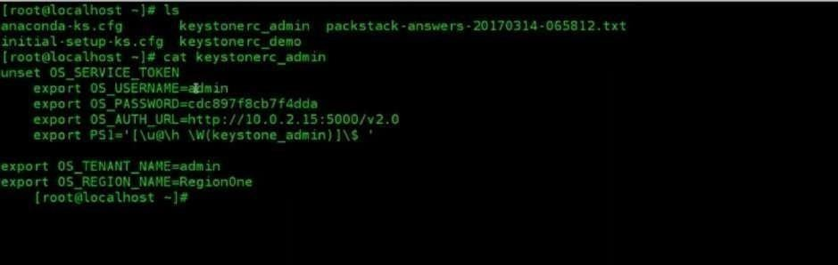

**Step 13:** Click the URL and enter the user name and password to start OpenStack



## OpenStack is successfully launched in your machine







**Result:**

Thus the OpenStack Installation is executed successfully.







|  |  |  |  |  |  |  |  |  |  |
| --- | --- | --- | --- | --- | --- | --- | --- | --- | --- |
|  |  |  |  |  |  |  |  |  |  |
|  | | | | | | | | | |















 



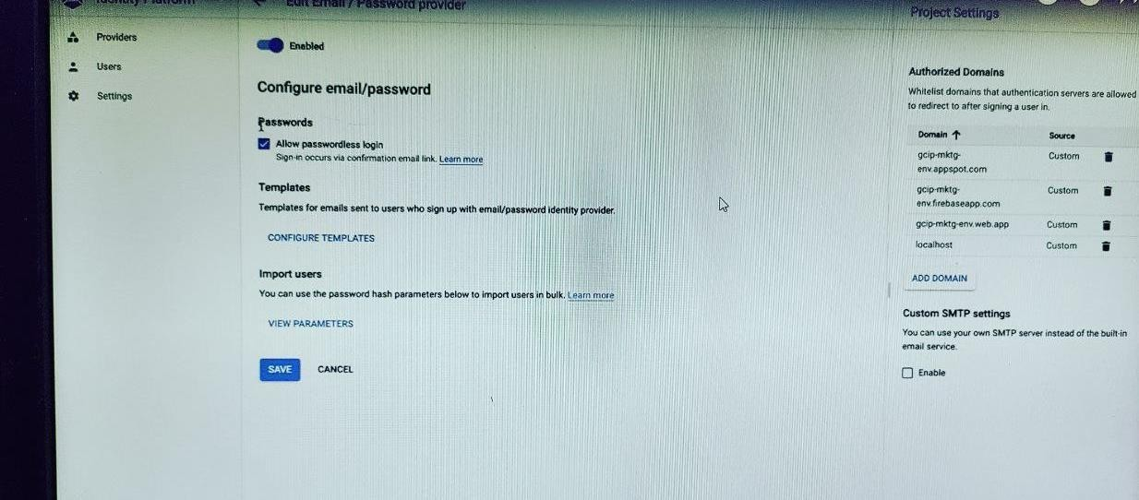

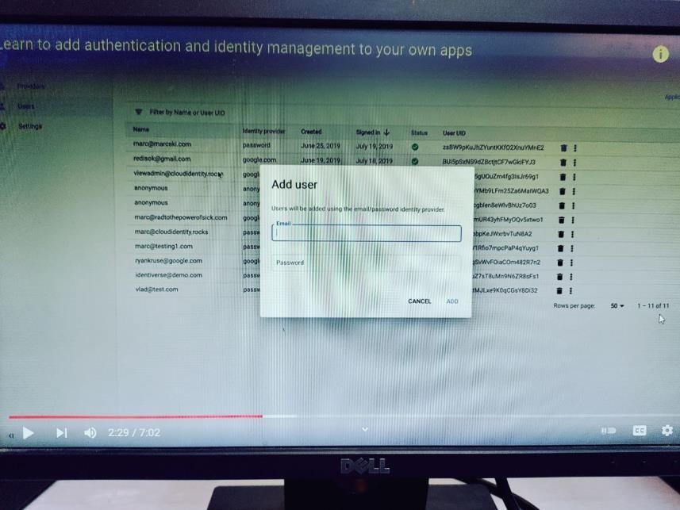





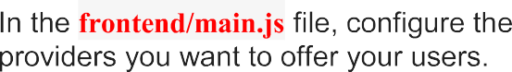

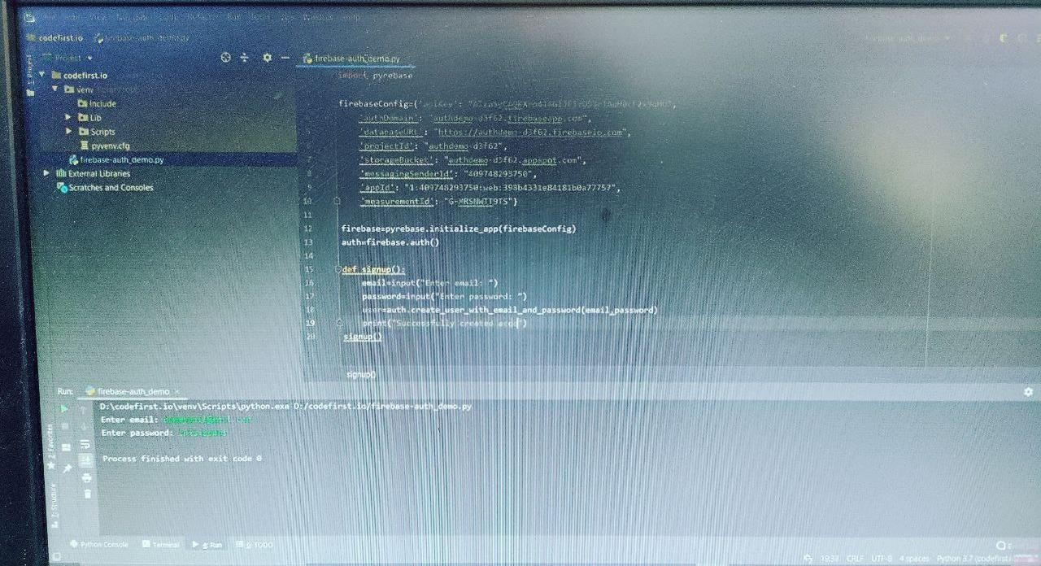

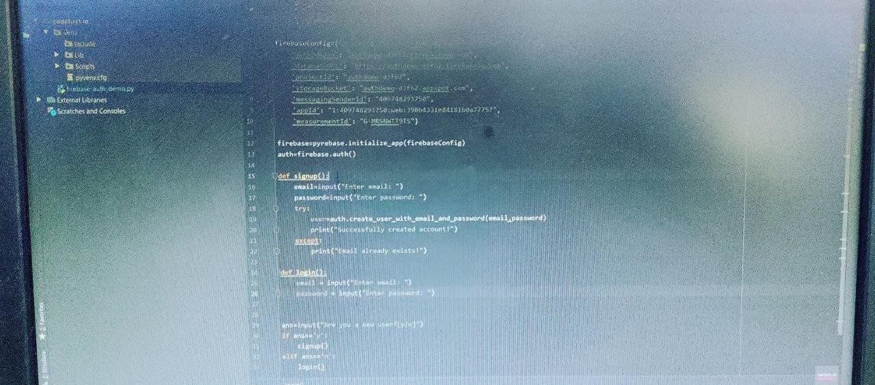

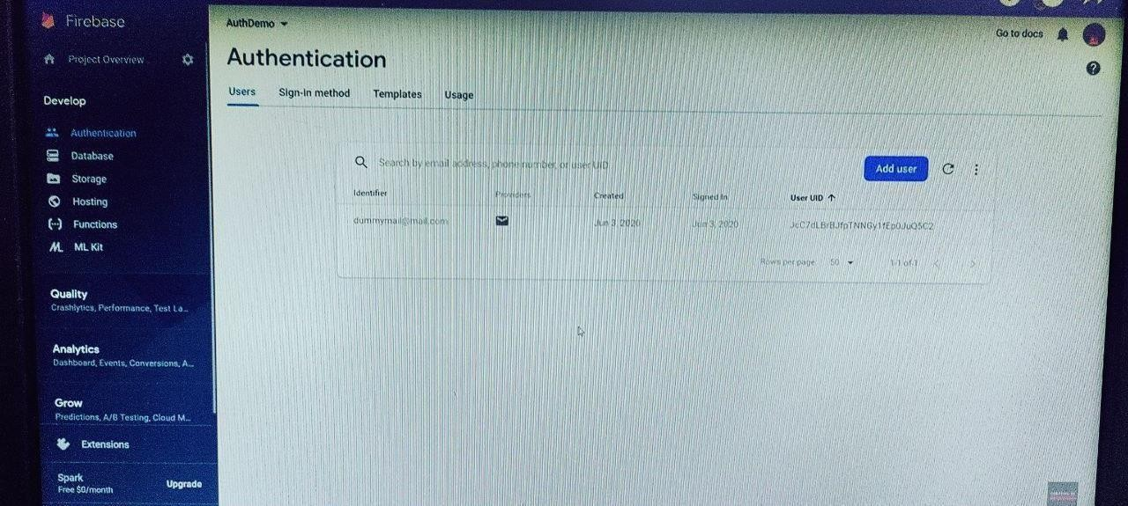



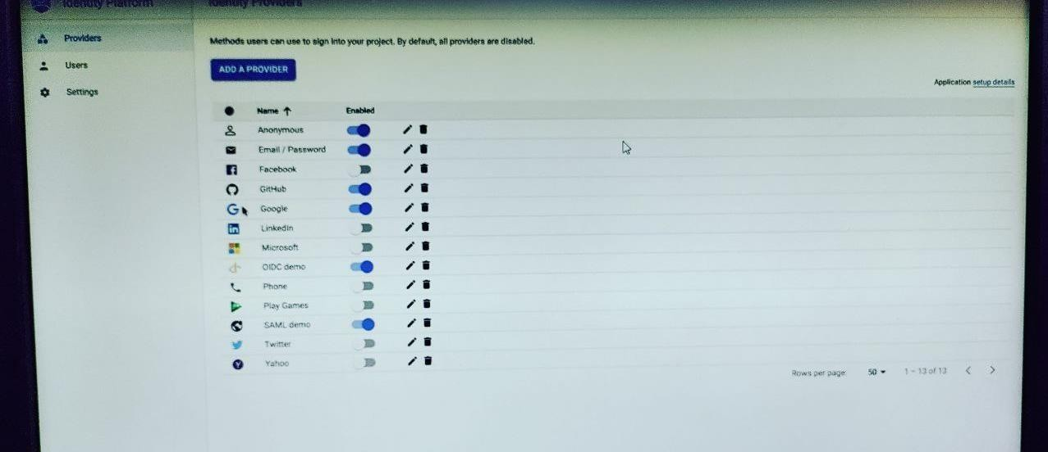

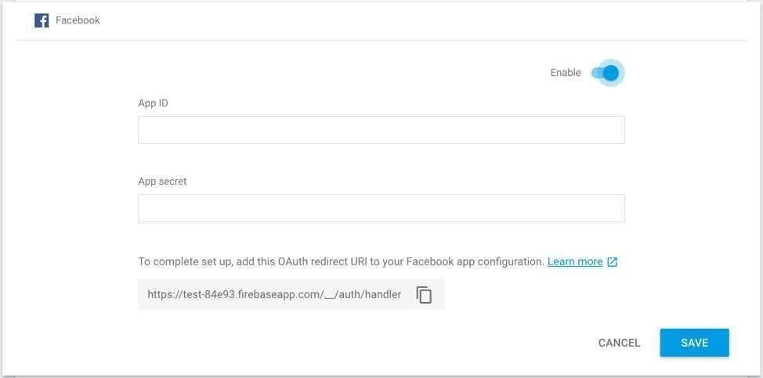

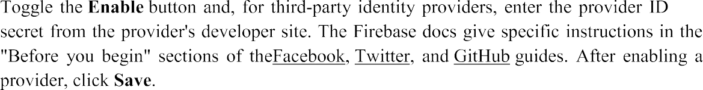









1